Table of Contents

Introduction 2

Code 2

License 2

Contact 3

Quick Reference 3

MVX Components 4

Powering On/Off the MVX 9

Connecting CETAC to the MVX 10

Priming Pumps in CETAC 13

Setting PRM Temperature in CETAC 17

Sample Order in CETAC 20

Manual Sample Introduction to NS300 22

Setting Focus in NTA 25

Detailed SOP 27

CETAC Script Explanation 38

Sample List File 43

Explanation of NanoSight Automation Signaling 44

Creating an NTA Acquisition Script 45

Creating an NTA Processing Script 45

Creating a CETAC Workstation Script 45

Arduino Wiring 46

Troubleshooting 47

Miscellaneous 47

# Introduction

This guide assumes some familiarity with the MVX autosampler and its controlling software CETAC Automation as well as with the NS300 and its controlling software NTA 3.3. For more information on the MVX or NS300 and their software see the individual guides available from their manufacturers. This guide also assumes that the MVX is using the [specific name of sample plates here], so any quoted z depth numbers may not be accurate for a different set up.

NanoSight Automation is a program written in Python 3.6 to coordinate the functions of the NS300 and MVX 7100 autosampler for the purpose of automating NanoSight sample acquisition and analysis. This is done by detecting certain “signals” from each of the individual machine’s control programs and programmatically moving and clicking the mouse as necessary to acquire and analyze each sample. The rest of the guide will explain how to set each machine’s control programs up correctly as well as how to create the necessary Sample List File for the NanoSight Automation program.

Note: This program was created specifically for The Center for Environmental and Systems Biochemistry (CESB) at the University of Kentucky (UK), so some aspects of the below procedures are specific to protocols developed there. If adapting this for use elsewhere it is up to the user to determine the correct settings and protocol for their use case.

# Code

The NanoSight Automation code and Arduino code are available on GitHub at <https://github.com/ptth222/NanoSight_Automation>.

# License

This program is a free software; you can redistribute it and/or modify it under the terms of the GNU General Public License as published by the Free Software Foundation. See the file LICENSE for details.

# Contact

Travis Thompson

ptth222@uky.edu

# Quick Reference

* Confirm Arduino is connected to the computer and autosampler.
* Connect CETAC to autosampler and set PRM temperature (~8 C) in Manual Controls.
* Check for air in all of the tubing. Prime until there is no air.
* Open the script to be used in CETAC, select the sample positions, and set z depth (45).
* Set camera level to 14, detection threshold to 4, and uncheck date time (click Create Script so the uncheck will take).
* Set Focus to 123, or adjust manually.
* Open NanoSight Automation and load the Sample List File.
* Click Start Batch to start the batch.

# MVX Components

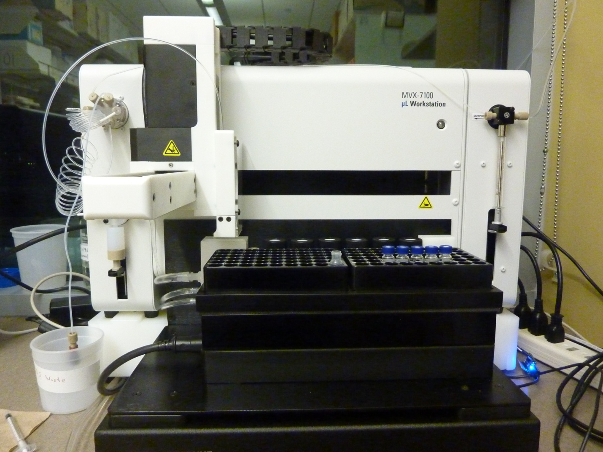

Pump Address

16

6-port Valve

Peltier Rack Module (PRM)

Pump Address

1

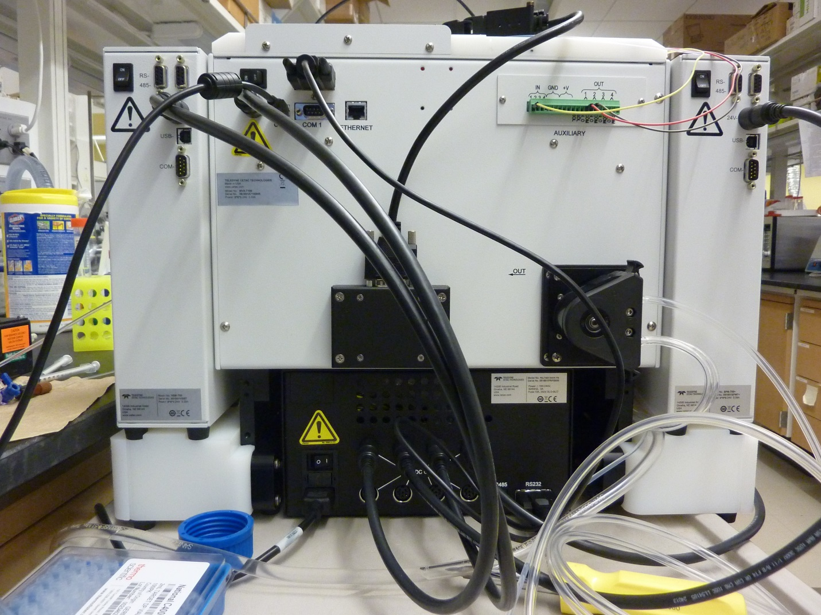

Digital I/O

Power Supply

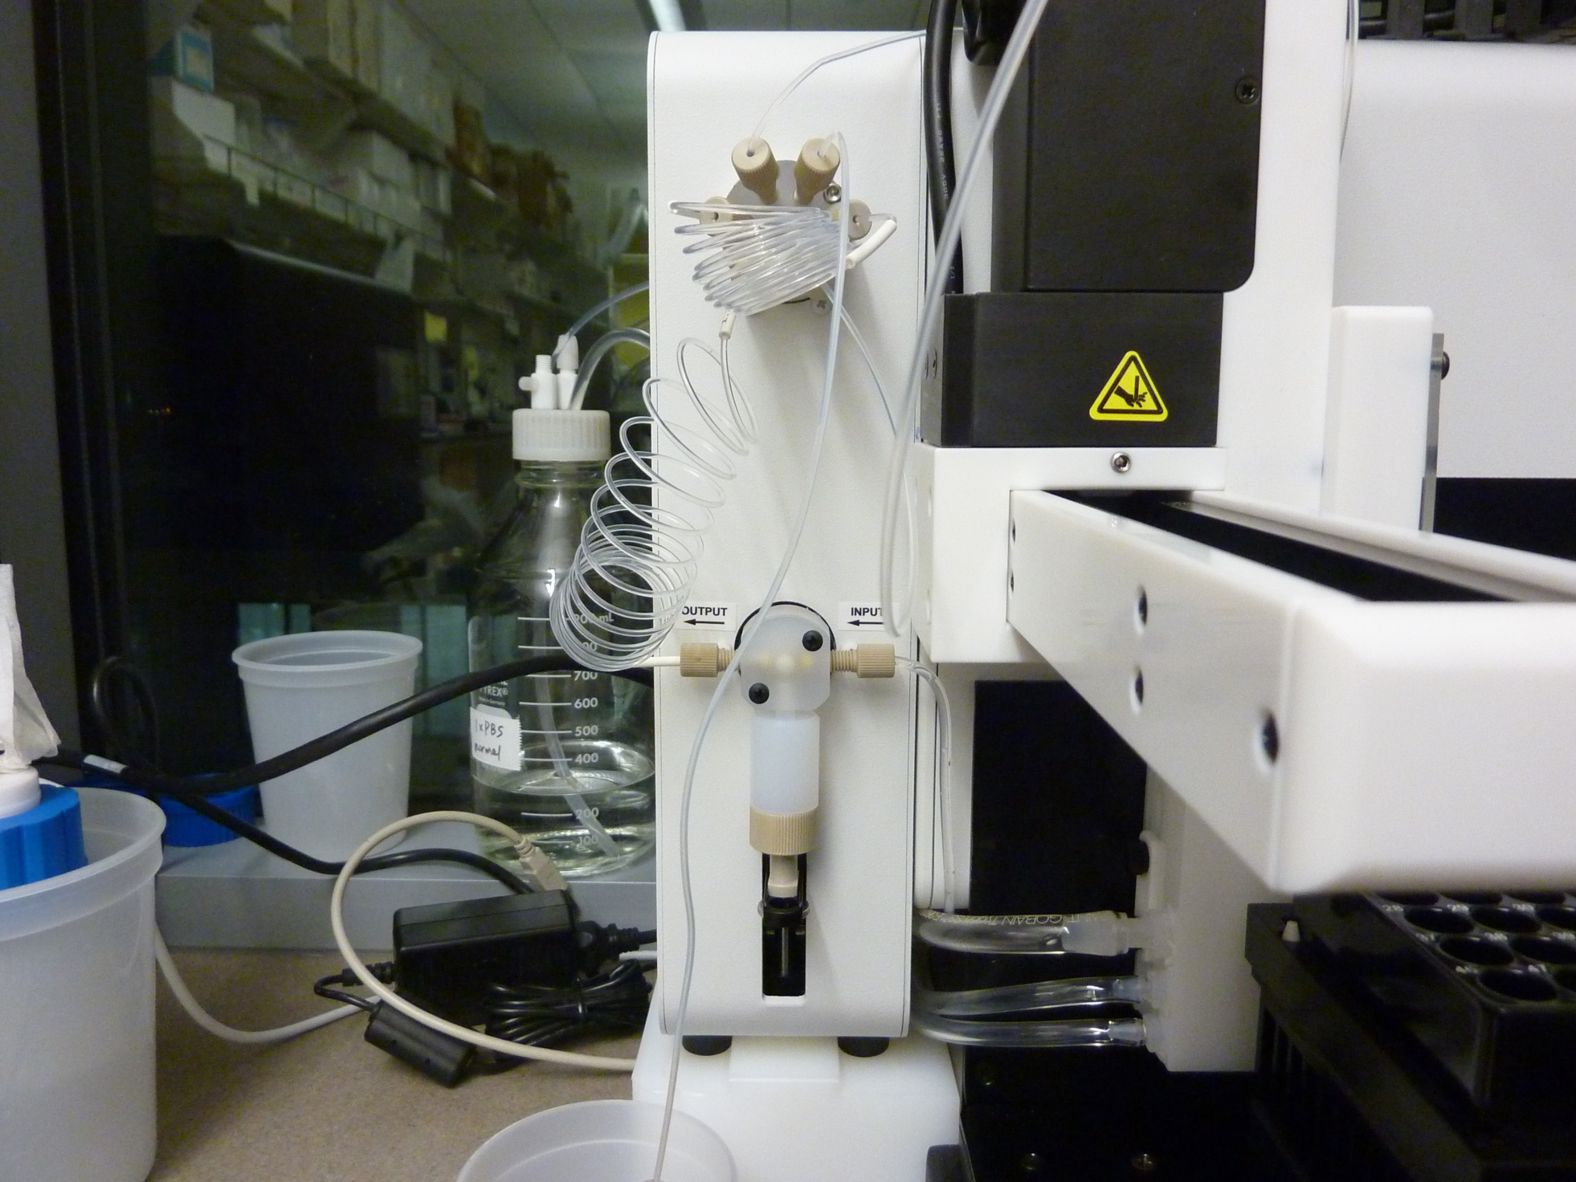

Sample Loop

Sample Overflow Loop

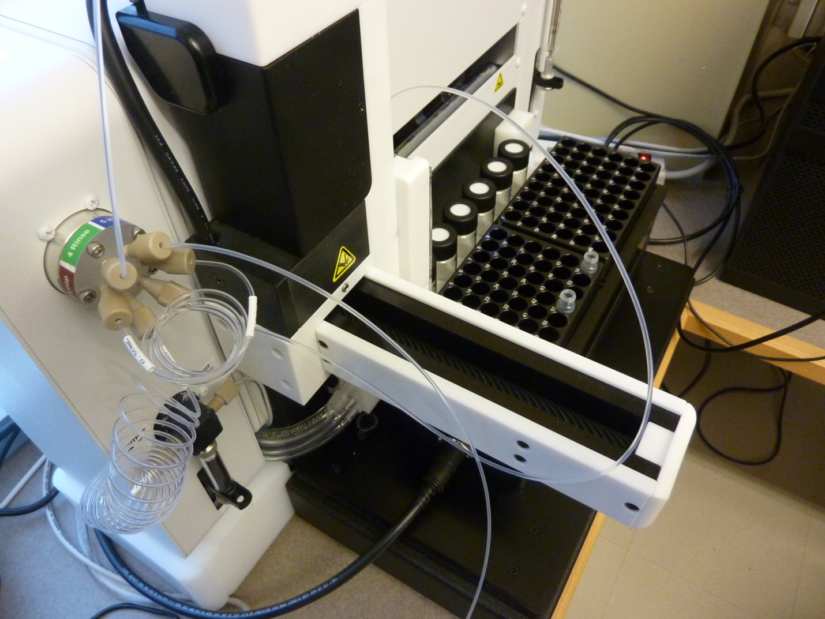

Probe Tubing

The Sample Acquisition tubing is comprised of the sample overflow loop and the probe tubing. Depending on the state of the 6-port valve the sample loop can be inserted between the overflow loop and the probe tubing. If the 6-port valve is set to Load then the sample loop will be included in the Sample Acquisition tubing. Pump address 16 is the syringe pump that controls the flow through the Sample Acquisition tubing.

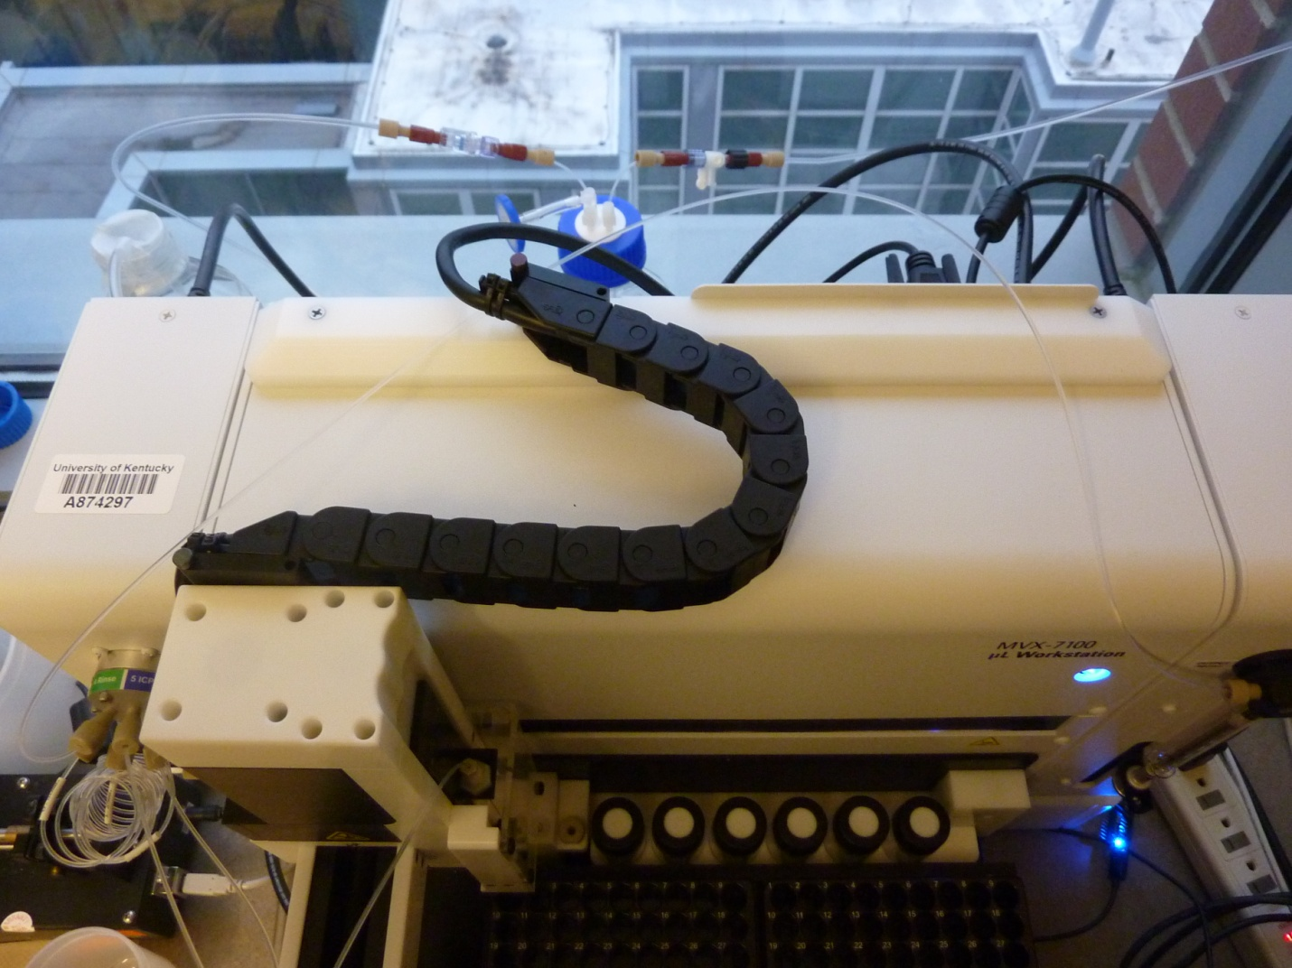

Drive Output Tubing

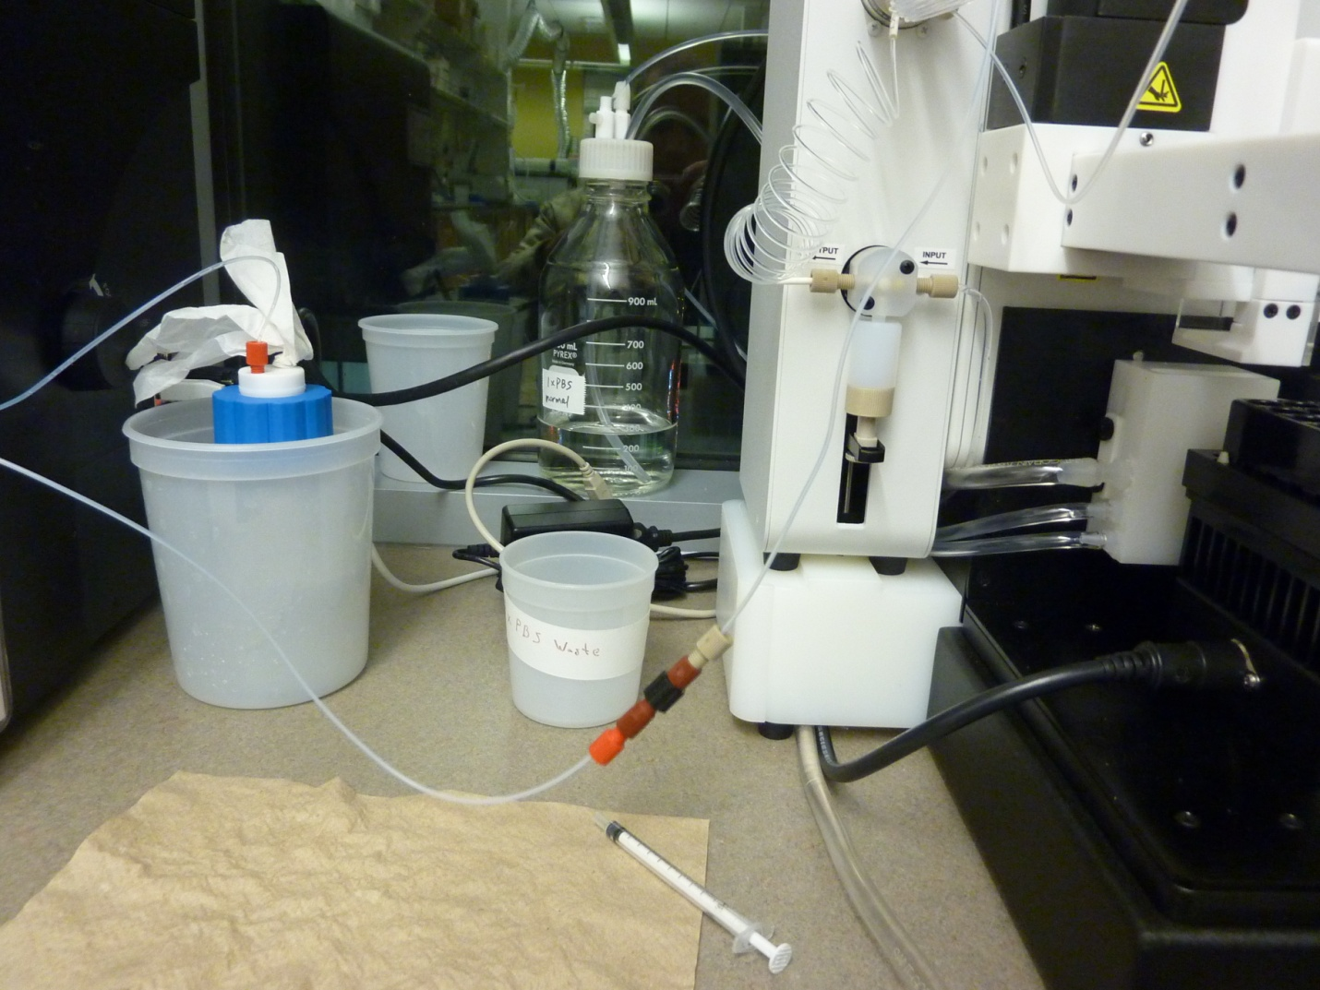

Exit Tubing

The Sample Injection tubing is comprised of the drive output tubing and the exit tubing. Depending on the state of the 6-port valve the sample loop can be inserted between the drive output tubing and the exit tubing. If the 6-port valve is set to Inject then the sample loop will be included in the Sample Injection tubing. Pump address 1 is the syringe pump that controls the flow through the Sample Injection tubing.

# Powering On/Off the MVX

There are several components that make up the MVX 7100 and some of them must be powered on/off individually and in a certain order. There are 4 total power switches on the back of the MVX. There is a switch for the power supply, a switch for the autosampler, and a switch for each syringe pump.



First on. Last off.

The power supply must be turned on first, then the autosampler and syringe pumps can be turned on in any order. When turning the MVX off the syringe pumps and autosampler must be turned off first and then the power supply. It is advisable to wait a couple of seconds after powering on or off each device before powering on or off another one. Note that when the power supply is turned on if the PRM cable is connected to it the PRM is automatically turned on and starts cooling to 4 °C.

# Connecting CETAC to the MVX

The CETAC Workstation program communicates with the MVX through USB, and the connection must be initialized. To initialize communication, go to the Home tab, and hit the Refresh button to have the program look for connections.

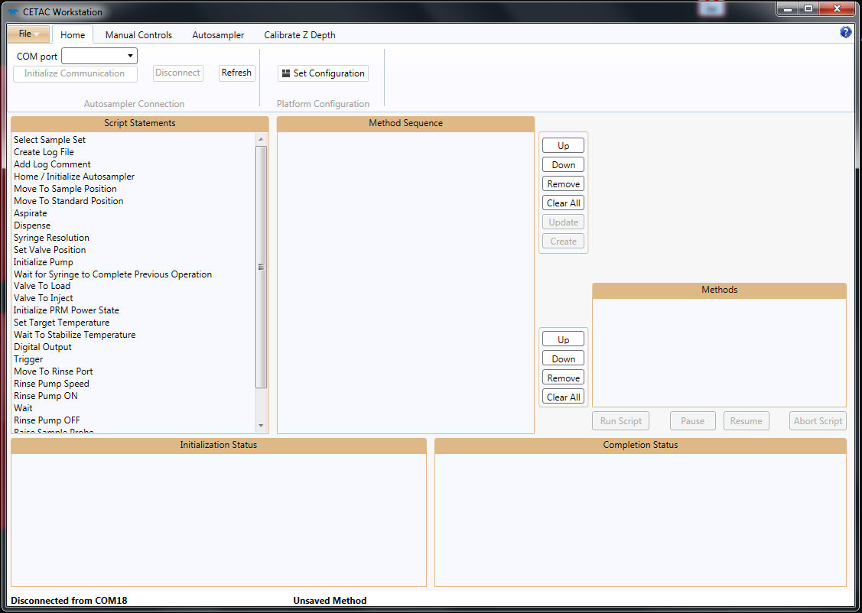

Select the correct COM port from the dropdown menu (typically port 18), and hit the Initialize Connection button. The initialization will take a little time.

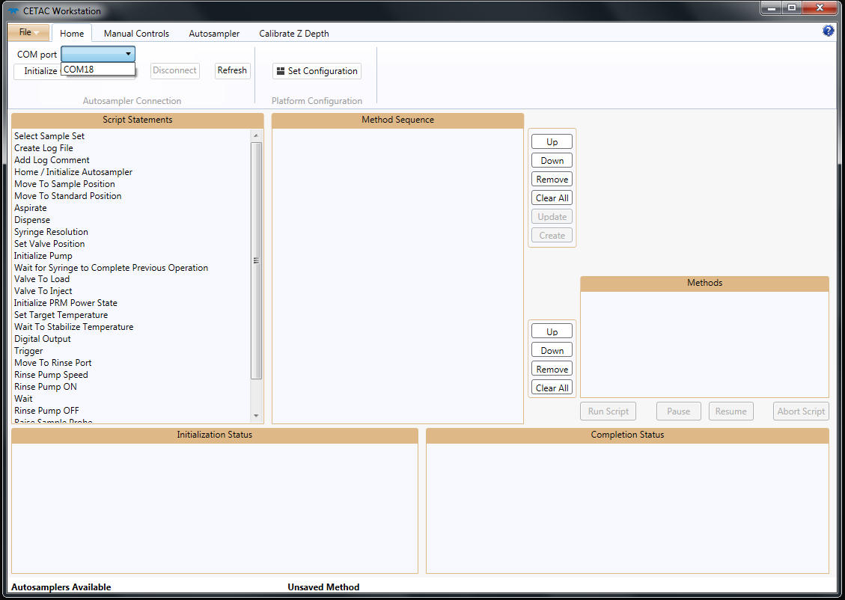

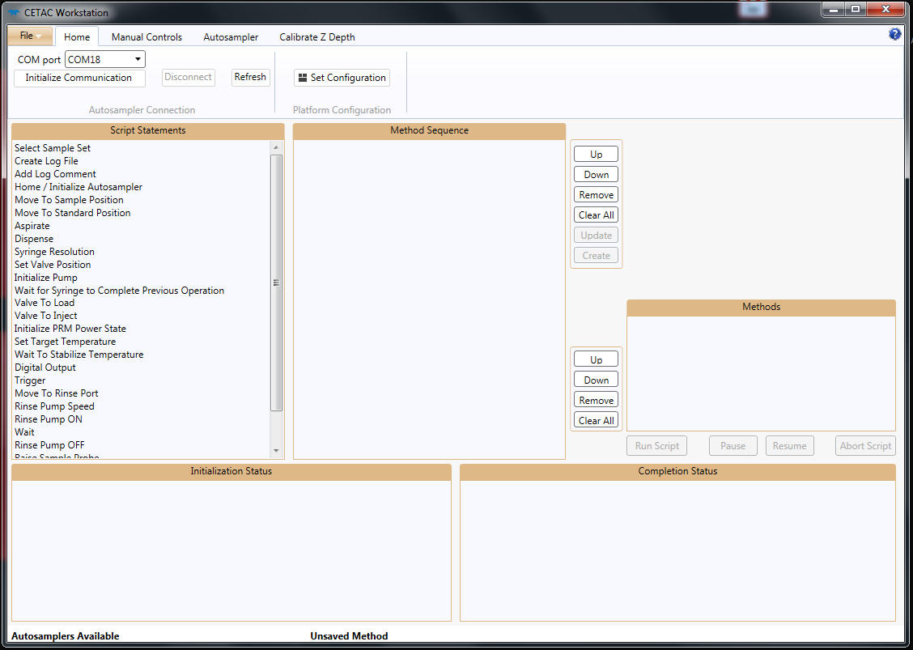

If no COM port appears in the drop-down check that the MVX is powered on and that the USB cable is pushed all the way in on both the MVX and the PC and click Refresh again. If there is still no COM port then power cycle both the MVX and PC and try again. If there is still no port then there is something wrong outside the scope of this document and help should be sought elsewhere.

# Priming Pumps in CETAC

Priming a pump means that the pump will aspirate one full syringe barrel through the input tubing and dispense it out the output tubing. Whether or not the output tubing includes the sample loop tubing depends on the state of the 6-port valve. If the sample loop is in the outflow path then any fluid primed with the pump will pass through the sample loop. The volume of fluid primed depends on the syringe being used in the pump. If the pump is using a syringe with a max volume of 500 uL then 1 priming will aspirate and dispense 500 uL. The amount of fluid primed will always be equal to the max volume of the syringe being used.

|  |  |  |
| --- | --- | --- |
| **Pump Address** | **6-port Valve State** | **Sample Loop in Outflow?** |
| 1 | Load | No |
| Inject | Yes |
| 16 | Load | Yes |
| Inject | No |

To prime a line, go to the Manual Controls tab.

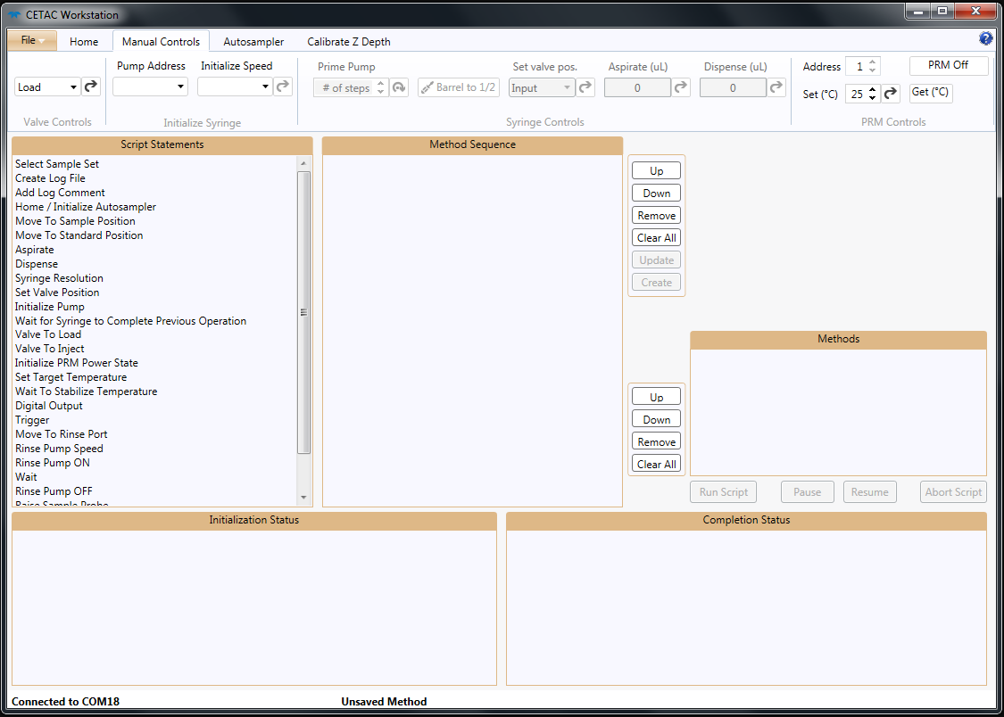

In the Valve Controls section set the valve position to include or exclude the sample loop as desired, and click the arrow button to send the setting.



Next, in the Initialize Syringe section, set the initialization speed as desired (Fast is recommended), the pump number to the desired pump to be primed, and click the arrow to initialize the pump.

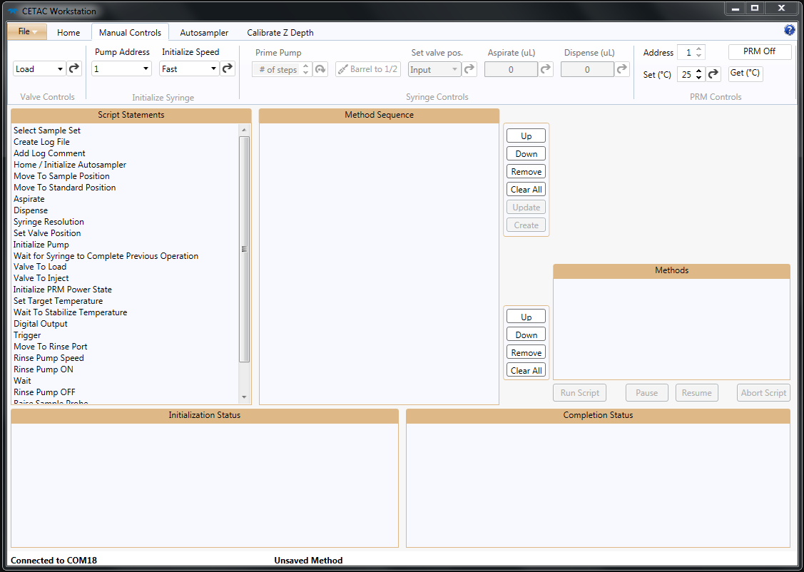

Depending on the starting state of the pump the initialization could take some time, so wait for the initialization to be completed (the plunger will be at the top of the syringe) before moving on. Then, in the Syringe Controls section, set the number of times to prime the pump and click the arrow button to begin priming. Do not send any other commands to this pump while it is priming or it will cause an error.

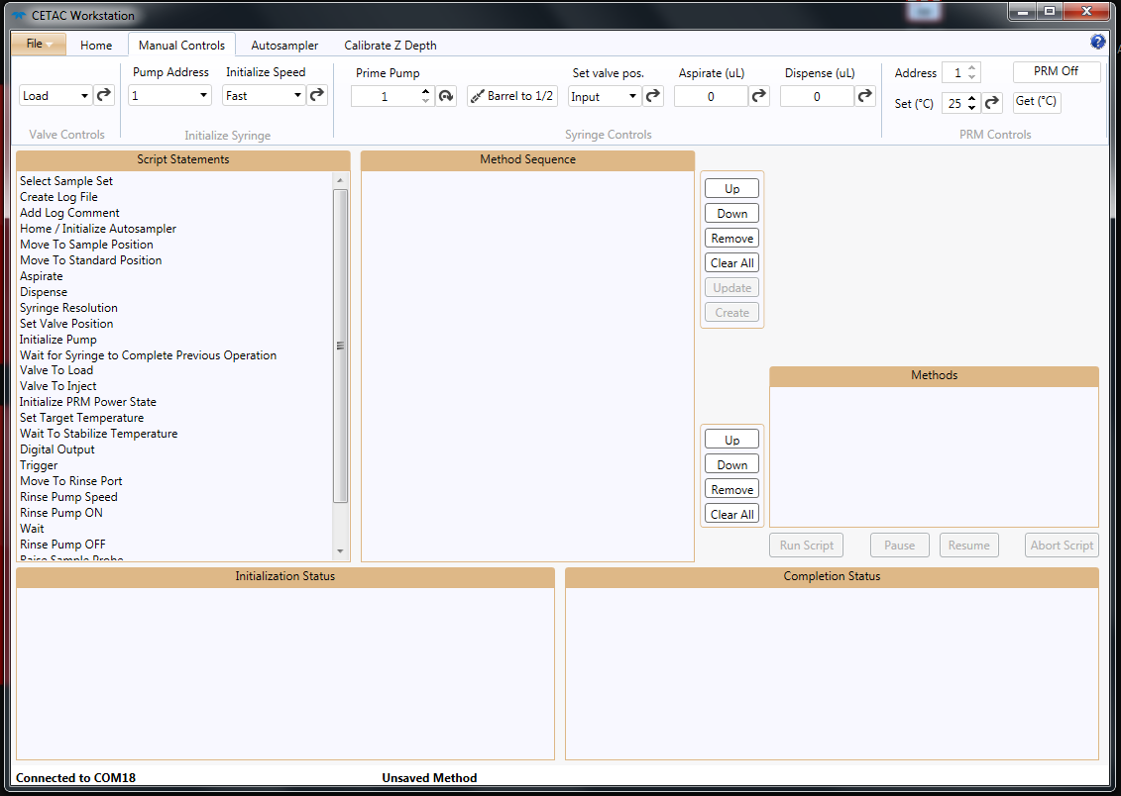

# Setting PRM Temperature in CETAC

The PRM or Peltier Rack Module can be used to help control the temperature of the samples loaded in the autosampler. It is important to set the temperature on the PRM almost immediately after powering on the MVX 7100 autosampler because the PRM will automatically start cooling down to its lowest temperature of 4 °C, and this can cause condensation to build up on the racks. Set the temperature so that condensation will not build up on the racks or so that build up is very slow (around 8 °C).

To set the PRM temperature, go to the Manual Controls tab.



In the PRM Controls section, set the desired temperature and hit the arrow button to send the setting to the PRM.



The current temperature of the PRM can be seen by pressing the Get (°C) button. The CETAC window may have to be widened for the PRM Controls section to display properly after polling the temperature.

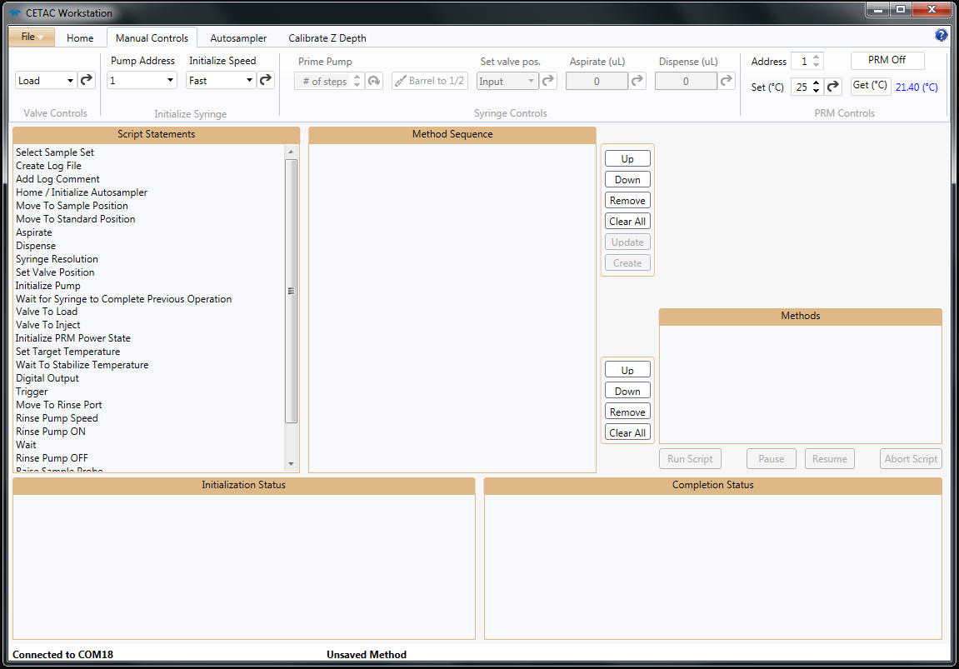

A blue light on the PRM will flash while the PRM is running and will be solid when it has reached its set temperature.

# Sample Order in CETAC

It is important to understand the order in which the autosampler will process the samples loaded in the racks. The autosampler will process samples from left to right and top to bottom where the top is the side closest to the syringe pumps. This is done for each rack separately, so the entire left rack is processed first and then the right rack is processed, similar to reading 2 pages in a book. It is imperative that the samples are loaded in the racks so that they are processed in the order that they are listed in the Sample List File for the NanoSight Automation program. If the samples are not in the same order as the Sample List File then the output file names will be incorrect.

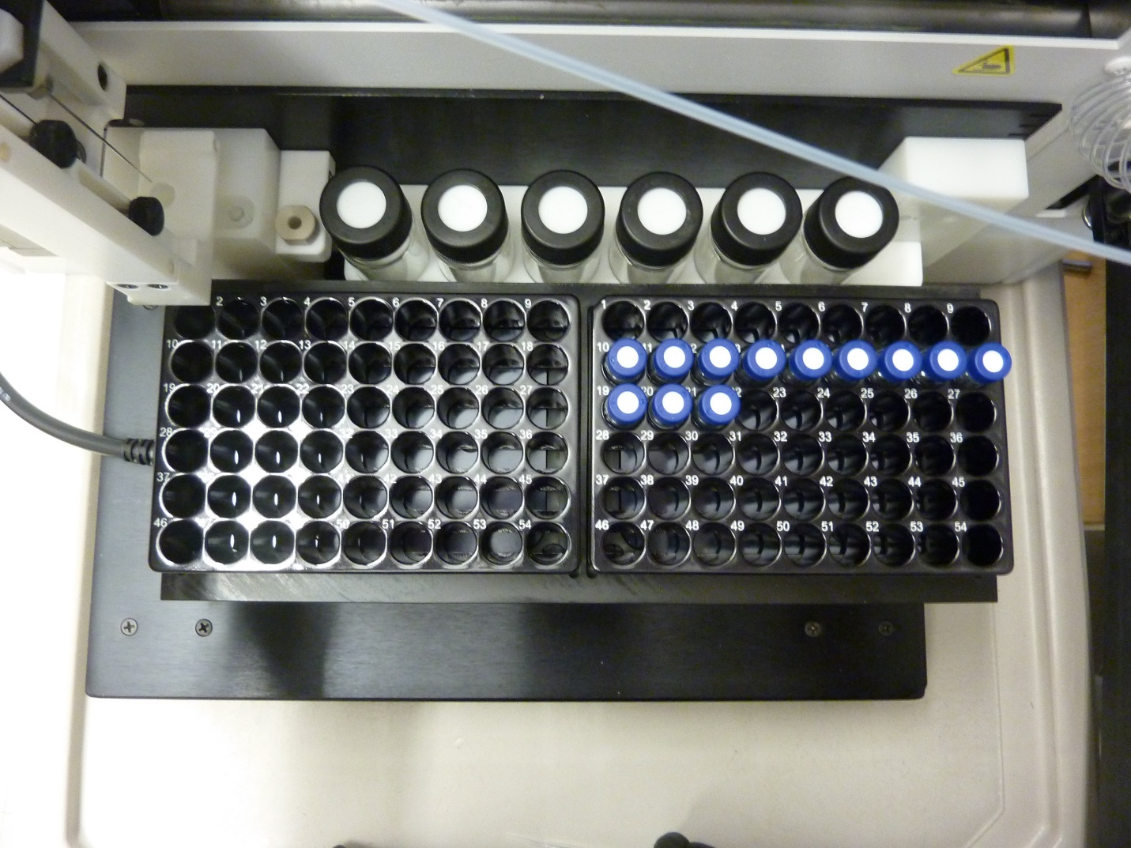

Tenth sample

Ninth sample

First sample

Rack 2 Processed Second

Rack 1 Processed First

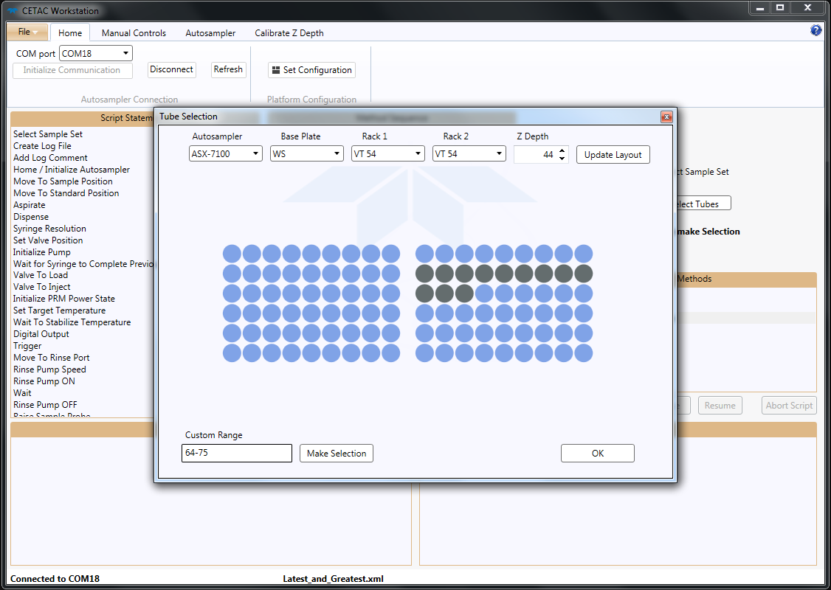

This should match the physical location in the racks.

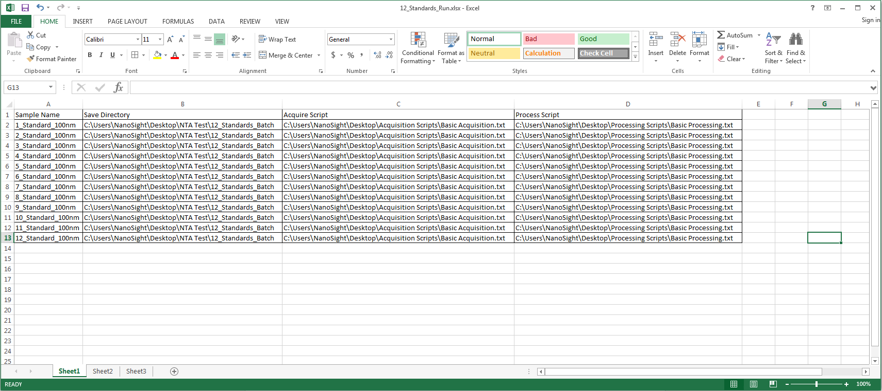

The order in the Sample List File should match the order in which the samples will be processed.

# Manual Sample Introduction to NS300

When using a syringe (1 mL volume) to manually introduce sample into the NS300 it is imperative not to introduce air into the system. The first step is to disconnect the line from the autosampler.

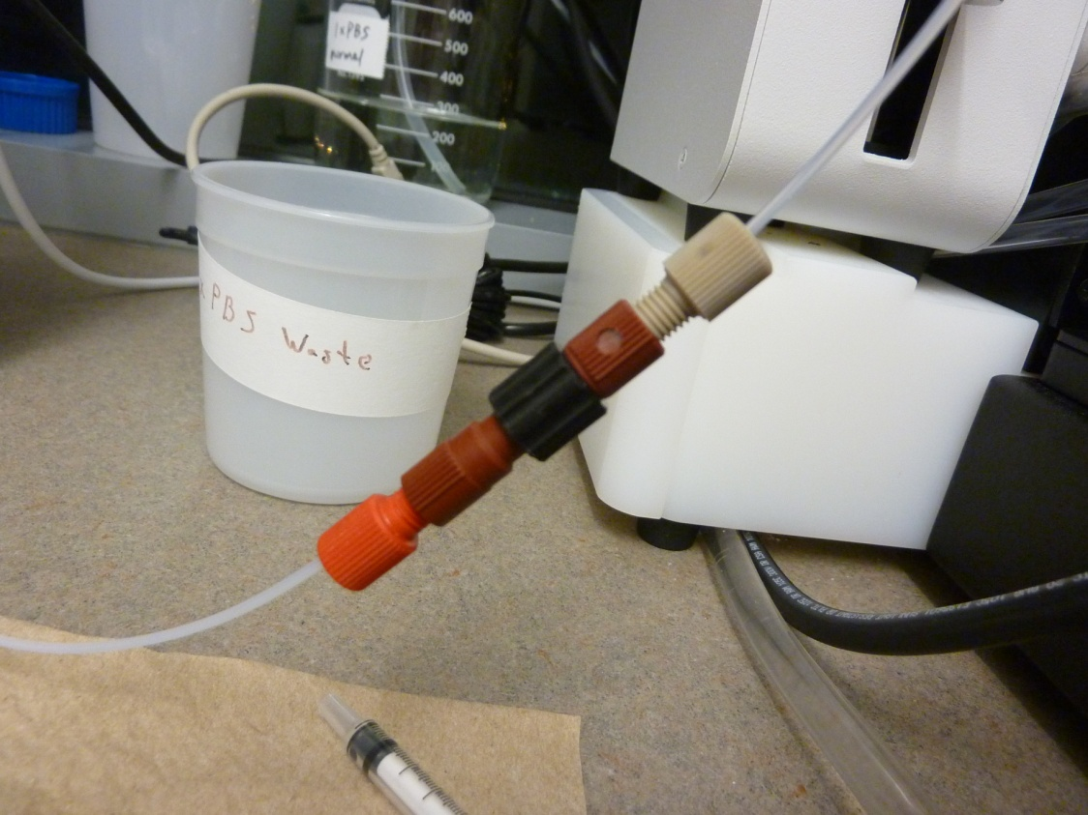

Twist the black collar to disconnect the 2 lines.

Next, fill the syringe with the fluid to be introduced into the NS300 (sample, PBS, water, etc.). Turn the syringe so the end is up and remove all of the air in the syringe. This is done by flicking the syringe until all of the air goes to the top and then advancing the plunger so that the air is pushed out and the fluid goes to the very end of the syringe.

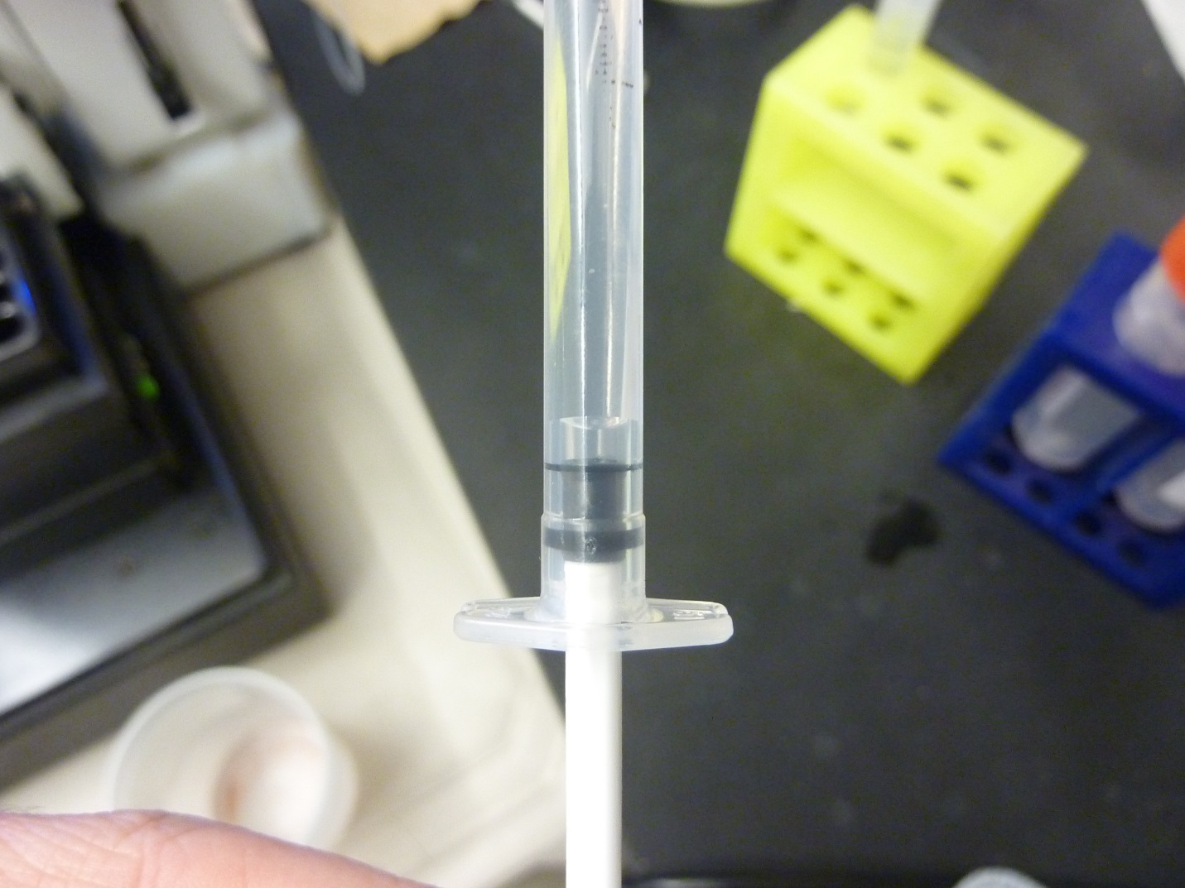

Air gap at plunger end.

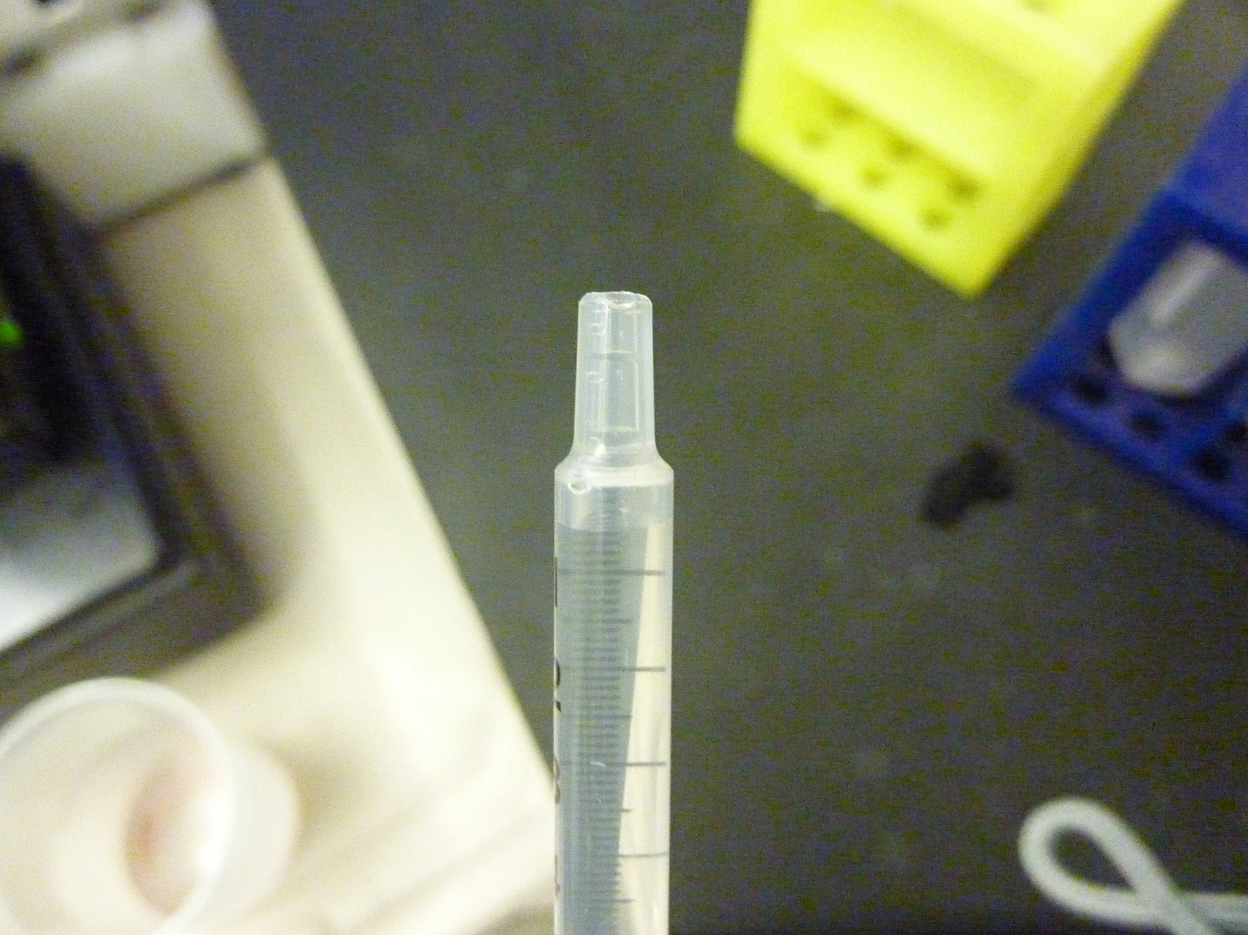

Air gap moved to open end.

Then, before inserting the syringe into the port, fill up the port with whatever is in the syringe by dripping it out of the syringe into the port. Make sure there are no air bubbles in the port after filling it up.

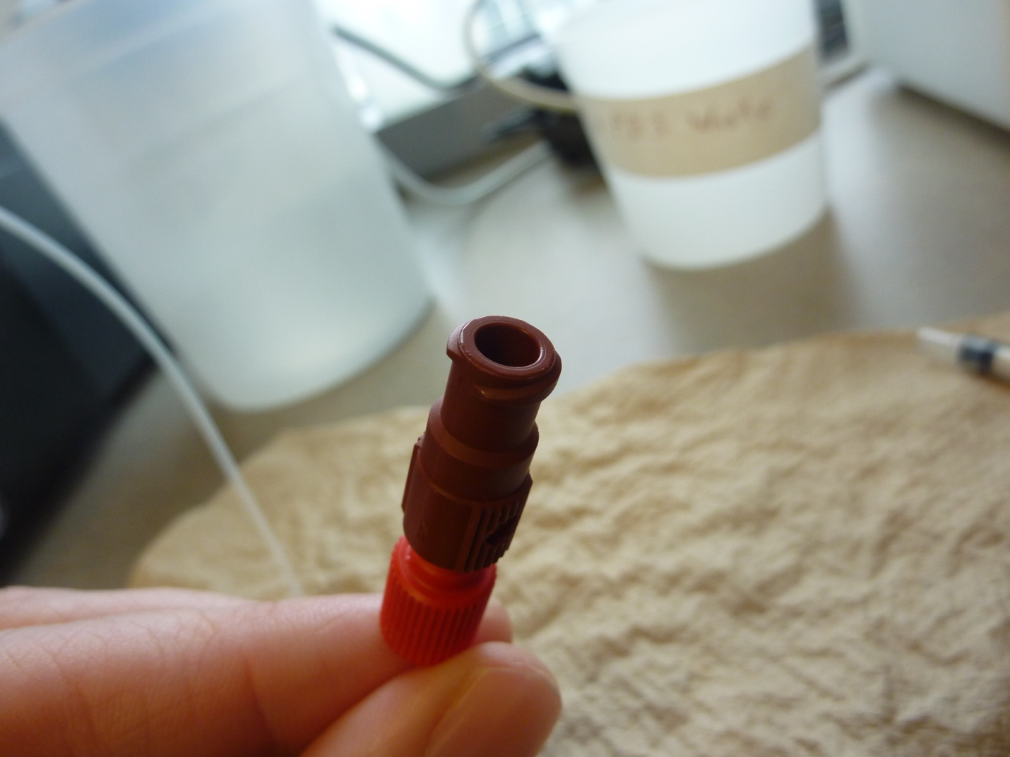

Port not full.

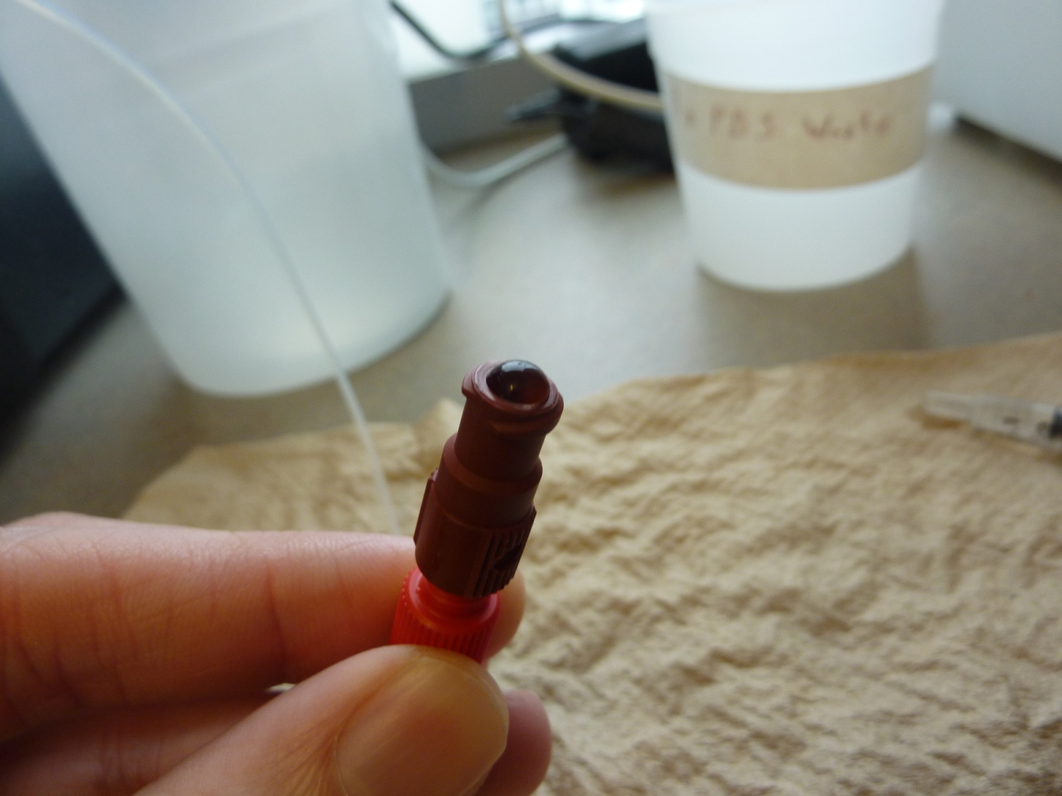

Port filled and ready for syringe.

The syringe can now be inserted into the port. Twist the syringe slightly when inserting into the port to get a better seal. Fluid should not be introduced into the NS300 faster than 3000 uL/min. The rule of thumb is that it should take 20 seconds to inject the 1 mL syringe into the NS300.

When reconnecting the line to the autosampler the port needs to be filled with water or PBS so no air is introduced.

# Setting Focus in NTA

To set the focus for a specific sample some sample first has to be introduced into the NS300. After introducing some sample into the NS300 turn the camera on and make sure some sample is visible. If there is no visible sample then either the camera is badly out of focus, or the sample was not pushed far enough in to be seen by the camera yet. Start by pushing more sample before adjusting the focus (the dead volume is around 150uL, so push at least 200uL to see sample on the camera). Now use the focus wheel on the side of the NS300 to try and bring the sample into focus. The wheel is a coarse adjustment and typically should not need to be moved very much, so adjust slowly and gently.

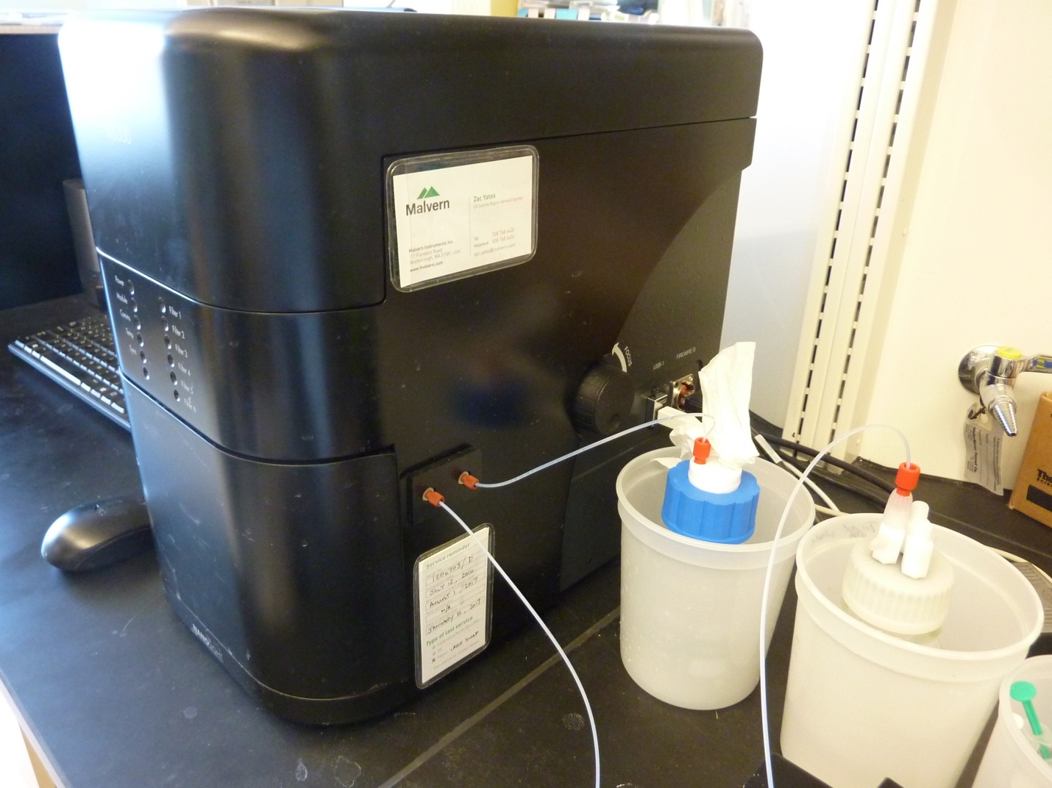

For a finer adjustment go to the Hardware > Focus tab in the NTA program and change the numbers there.

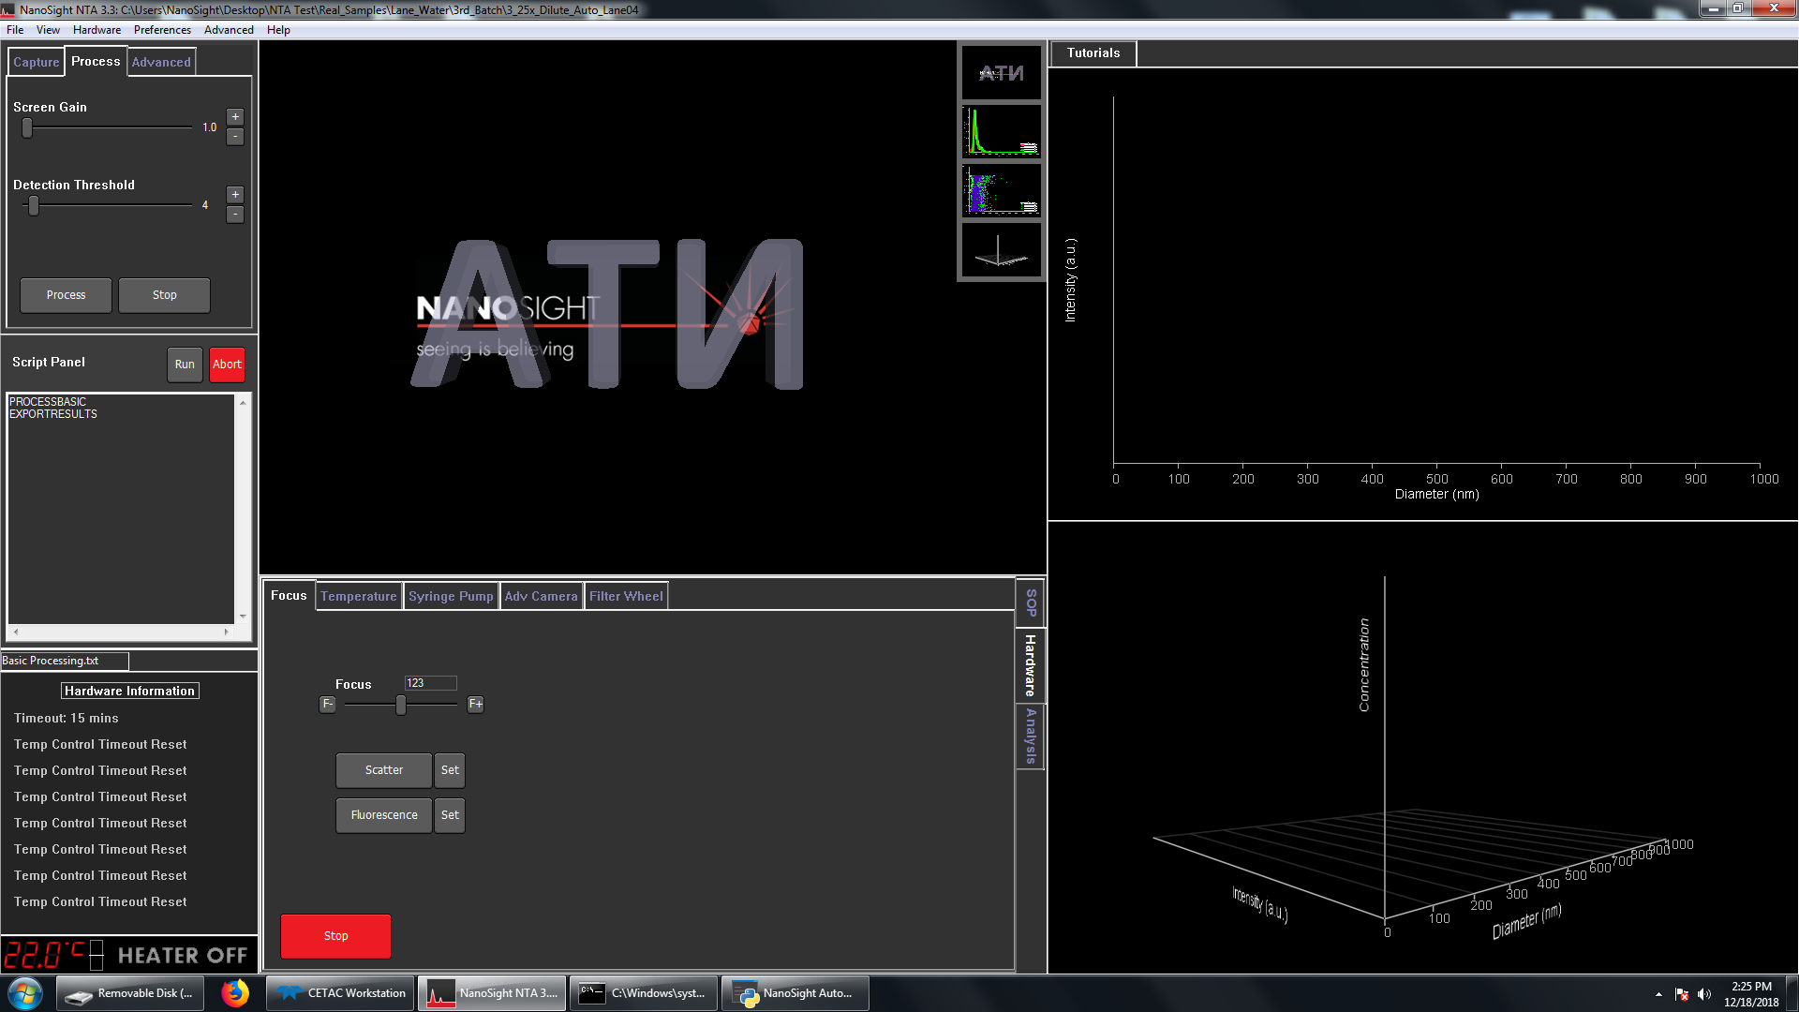

For more detail on setting the focus consult the NanoSight documentation.

# Detailed SOP

This SOP assumes the NS300 is in state that is ready for samples. That is to say that the lines have been cleared of air and are connected to the appropriate top-plate, and the top-plate is secured to the laser module. For more information on preparing and maintaining the NS300 see the documentation available from NanoSight (there should be a folder on the desktop with NS300 manuals).

Make sure the Arduino is connected to the PC through a USB port and the blue light is on.

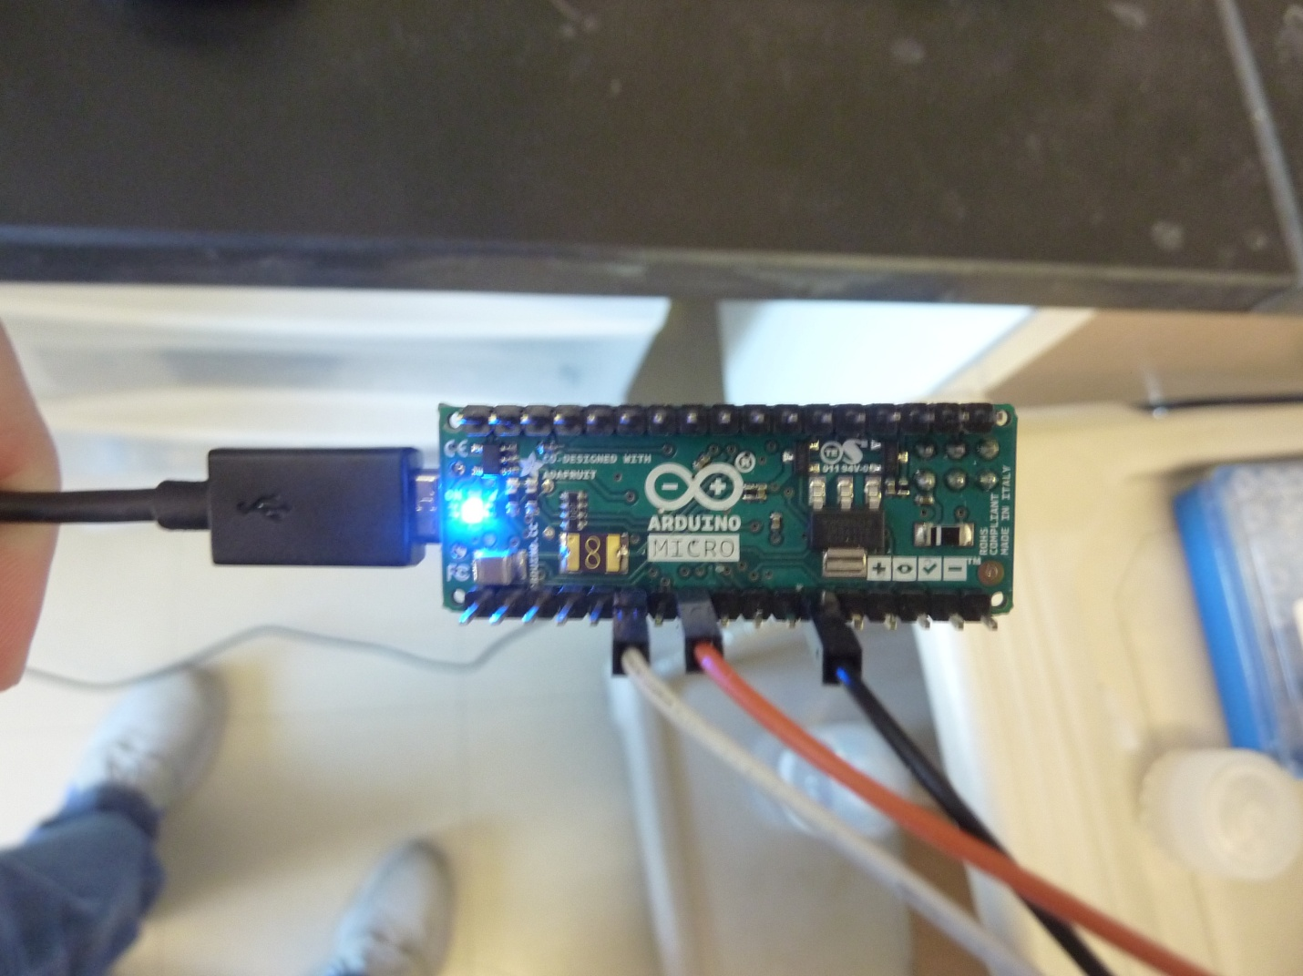

Confirm that all 3 wires from the Arduino are connected to the autosampler. There should be 1 wire in IN port 1 on the MVX connected to digital I\O port 5 on the Arduino, 1 wire in the left OUT port 1 on the MVX connected to digital I\O port 7 on the Arduino, and 1 wire in the right OUT port 1 on the MVX connected to GND on the Arduino.

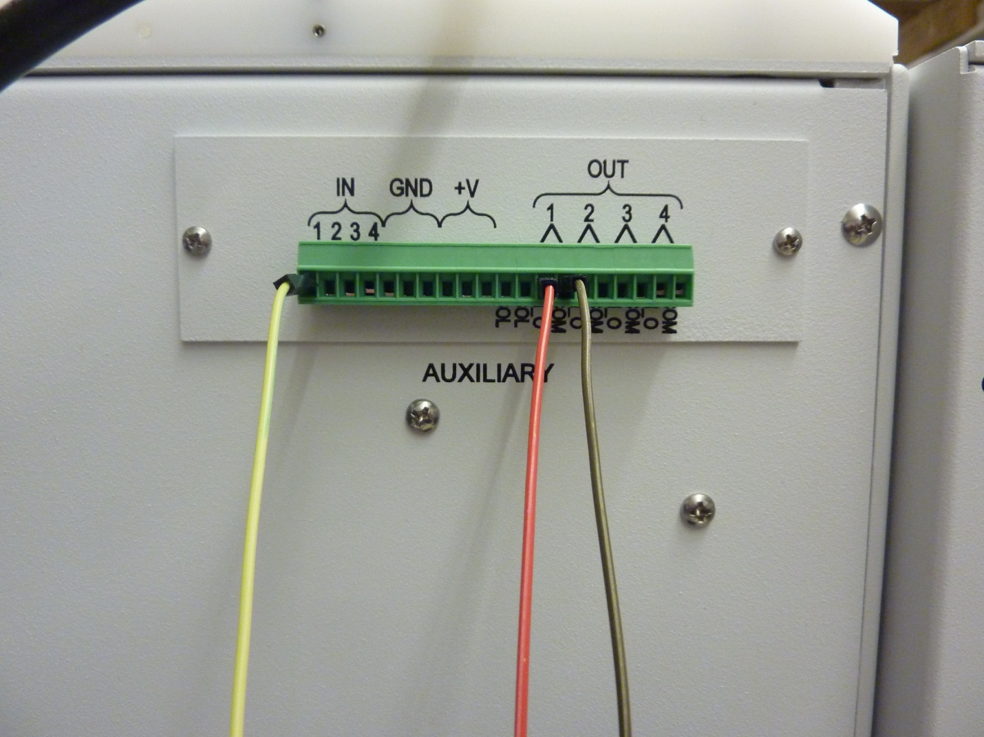

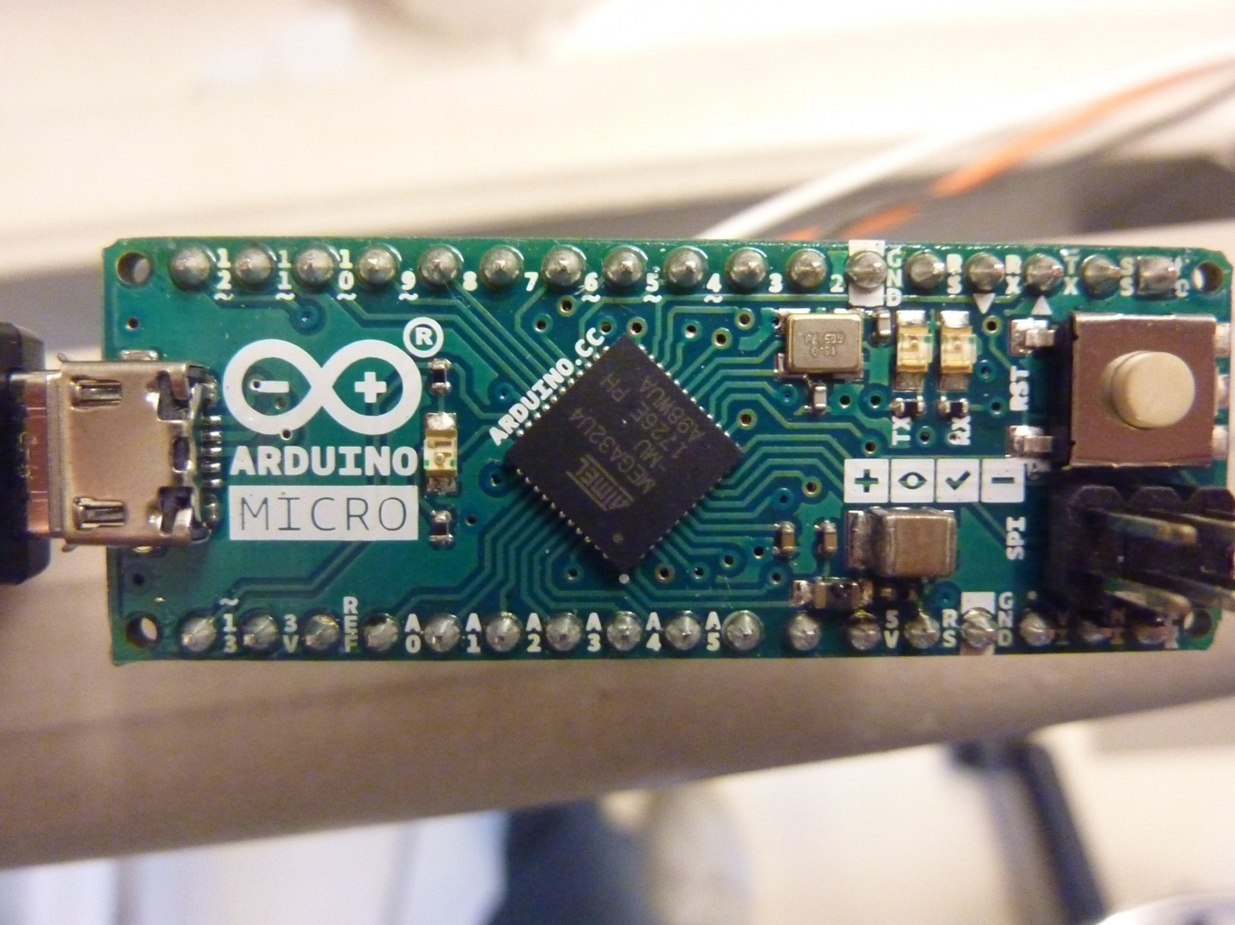

Turn on the power supply of the MVX. Wait a few seconds and then turn on the autosampler and the pumps. More information on powering on the MVX can be found in the “Powering On/Off the MVX” section.



First on. Last off.

Open the CETAC Automation program. In the Autosampler Connection section of the Home tab, look for a COM connection in the drop down next to “COM port”. If one does not appear, click the Refresh button. Once a COM port is found and selected click the Initialize Communication button. More information on connecting CETAC to the MVX can be found in the “Connecting CETAC to the MVX” section.



Go to the PRM Controls section of the Manual Controls tab, and set the PRM temperature to the desired setting (typically ~8 °C). Wait until the PRM has reached this temperature before loading samples. The temperature can be checked in the Manual Controls tab by pressing the Get (°C) button, but the CETAC window will need to be resized so the PRM Controls can be seen. If the PRM temperature is not set manually it will automatically cool down to 4 °C which will cause a lot of condensation to form. More information on the PRM can be found in the “Setting PRM Temperature in CETAC” section.



Visually inspect the sample introduction tubing to see if there is air in the lines. If there is air in the lines then they need to be primed until there is no air. Prime pump address 16 with the 6-port valve in the Load position. Directions for priming pumps are in the “Priming Pumps in CETAC” section, and more information on the MVX tubing is the “MVX Components” section.

The sample outflow tubing should be inspected for air in the lines as well. To clear these lines of air however, the tubing may need to be disconnected from the NanoSight or the flow diverted to the waste bottle in order to prevent the air from going into the NanoSight. If priming is needed, prime pump address 1 with the 6-port valve in the Load position.

Assuming the PRM is cooled down and the samples are loaded, open the script that the autosampler will follow for the batch (CESB_NanoSight_Automation.xml) by going to File>Open.

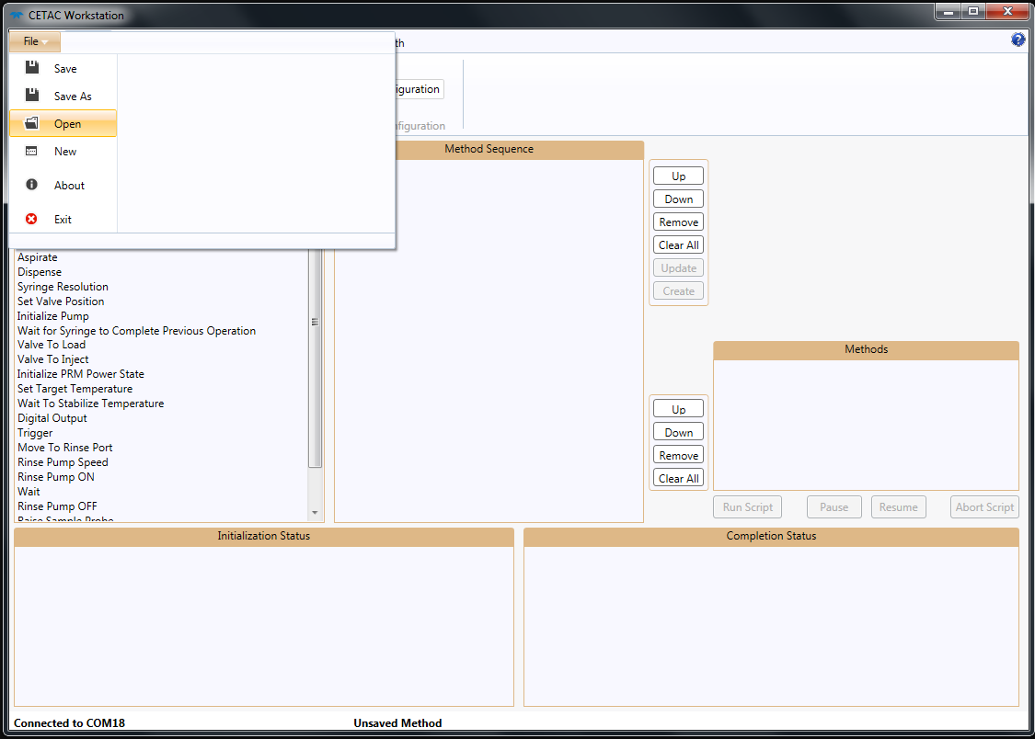

Find the method with the Select Sample Set instruction (PullInSampleAndCarrier) by double-clicking methods in the Methods list box to view their instructions in the Method Sequence list box. Double-click the Select Sample Set instruction and then click the Select Tubes button in the details of the instruction.

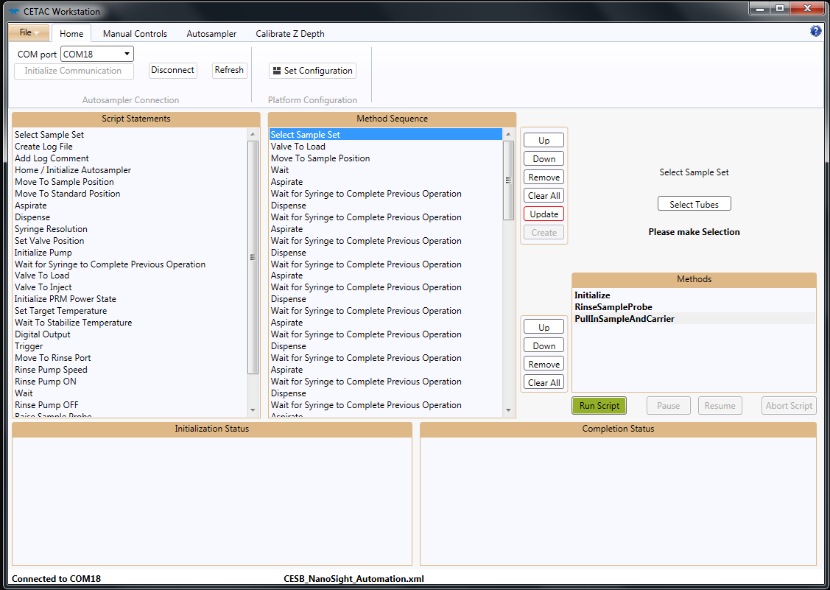

3

2

1

Match the selection to where the samples are physically loaded and set the z depth for how far down the probe should go in the sample (for samples with the spring and insert this will be 44 mm, and 45 mm without the insert). Be sure to click Update when finished. More information on ordering samples in the racks can be found in the “Sample Order in CETAC” section.





Turn on the NS300. Once the lights on the front have stopped blinking the NTA 3.3 program can be opened. In the Capture tab set the Camera Level to 14.

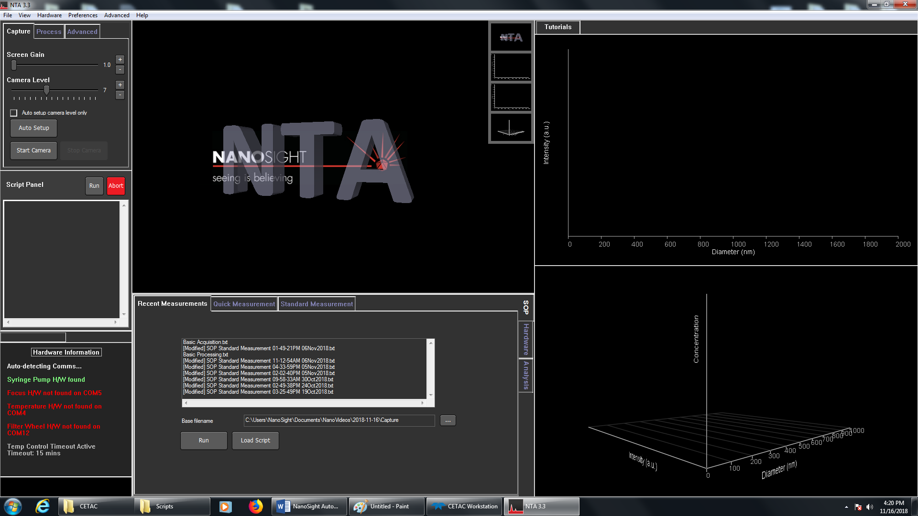

In the Process tab set the Detection Threshold to 4.

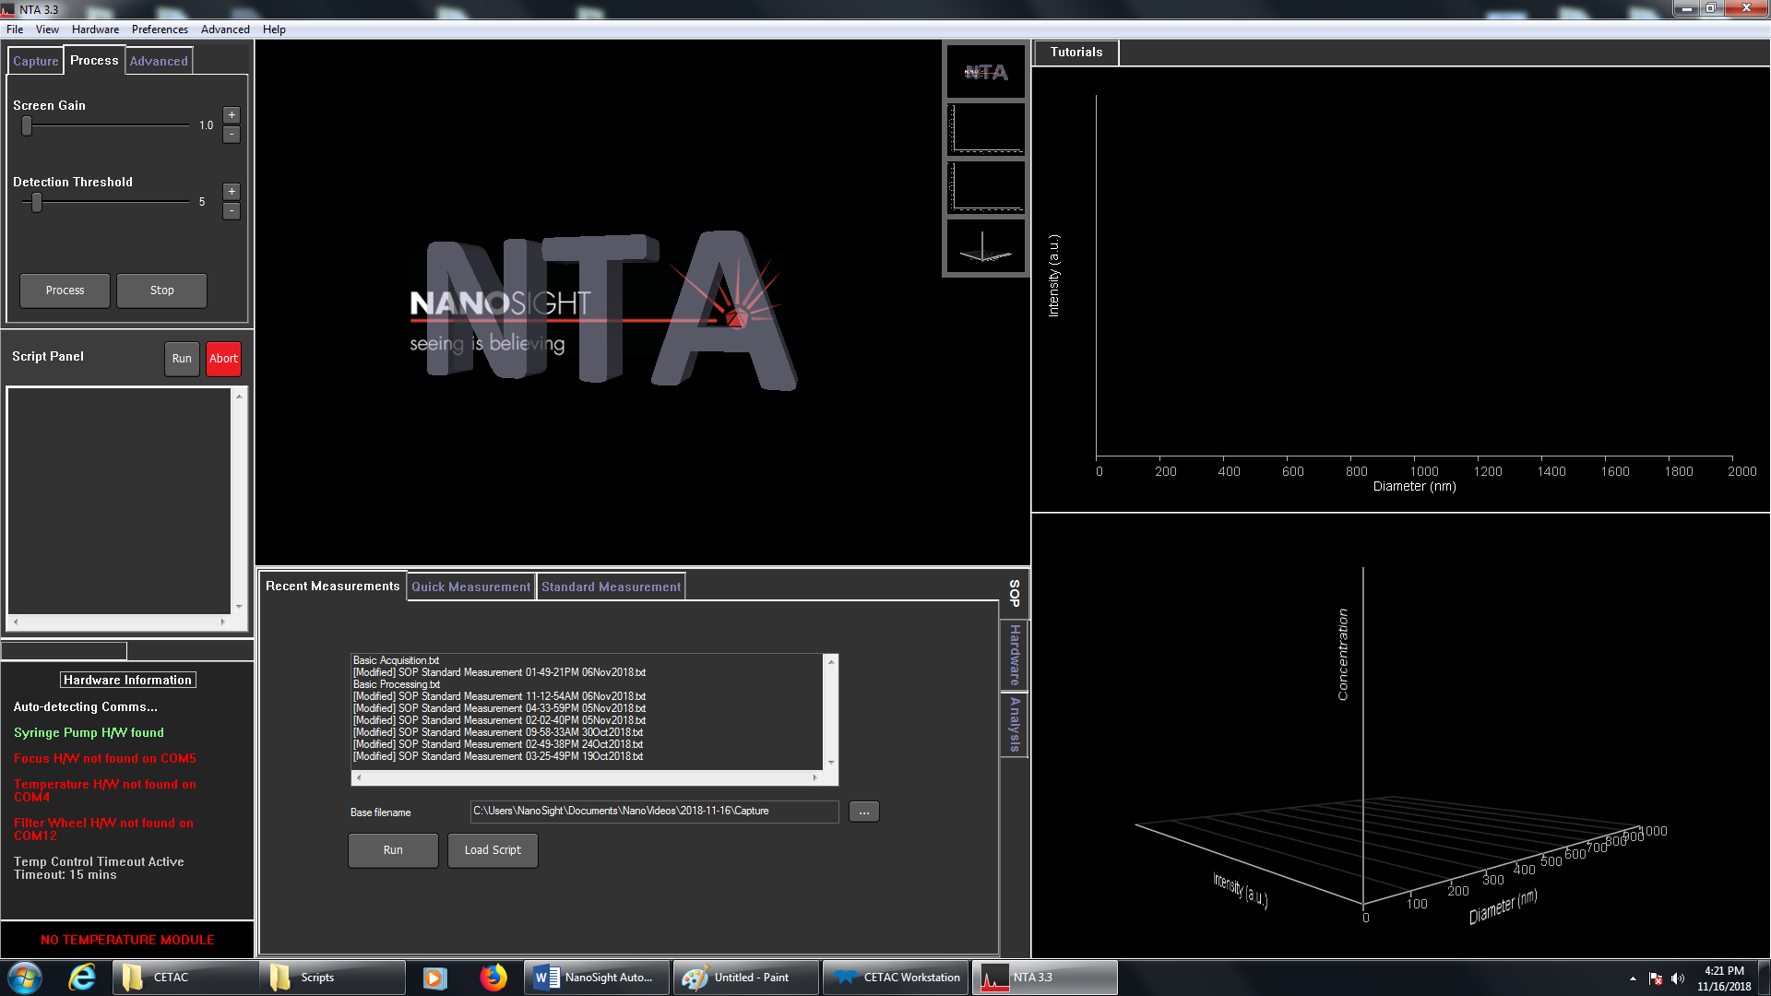

In the Standard Measurement tab uncheck the “Time and date filenames” checkbox. After unchecking the “Time and date filenames” option be sure to click Create Script or the “Time and date filenames” option will not be updated.

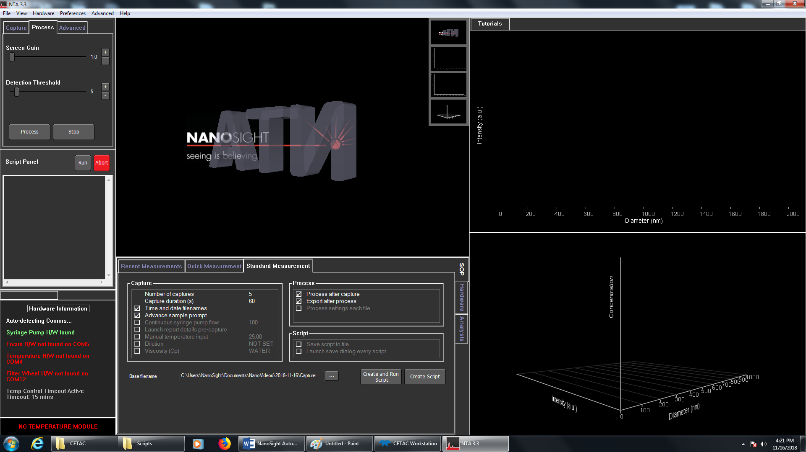

In the Hardware > Focus tabs set the Focus to 123.



If the samples to be ran are not exosomes or 100nm standard then the focus may need to be set manually. See the “Setting Focus in NTA” section for more details.

Open the NanoSight Automation program by double-clicking the “NanoSight Automation.bat” batch script. Load the appropriate Sample List File for the batch into the program by clicking the Open button and selecting the appropriate file.

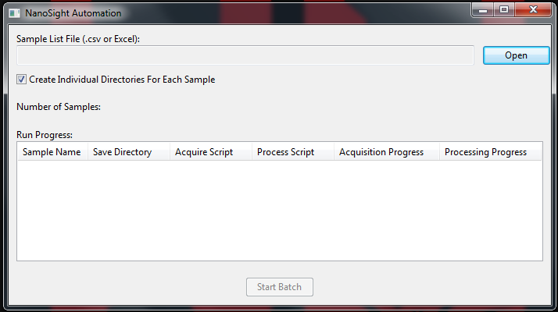

If each sample’s outputs should be in its own folder then leave the “Create Individual Directories For Each Sample” box checked. This option will create a new sub-folder in the save directory for each sample with the same name as the sample and save the outputs there. If the option is unchecked then each sample’s outputs will be saved in its indicated save directory. With the sample list loaded and the option checked or not, simply click Start Batch to start the batch.

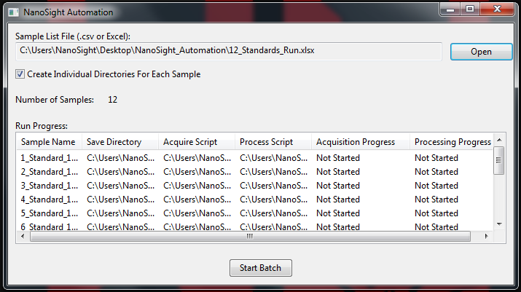

It is advised not to use the PC or move the mouse once the batch has started since it could cause an error in the program. The mouse is typically only needed by the program at the beginning of the batch and to switch between samples, so if the NanoSight is acquiring or analyzing a sample the mouse is safe to use. If the mouse needs to be used by the user make sure it is not near the end of an acquisition or analysis.

A new dialogue box will appear when the batch has completed. Once the batch is complete manually flush with 2 mL of nanopure water.

# CETAC Script Explanation

The script used in the CETAC Workstation program in the Detailed SOP section is described here. It was developed specifically for CESB. The first method, Initialize, simply sets the autosampler to its home position and initializes both of the syringe pumps. It runs once per batch. The RinseSampleProbe method rinses the probe and primes 400 uL through the Sample Acquisition tubing, including the sample loop. The priming is to make sure that there is no air in the lines. This method also runs once per batch. The last method, PullInSampleAndCarrier, is the bulk of the script. This method is where the samples for the batch are selected in the Select Sample Set command and this method repeats its commands for each sample selected. This method first sets the 6-port valve so that the sample loop is in the Sample Acquisition tubing. Then it moves the probe to the first sample in the batch and aspirates it into the sample loop at the same time that the other syringe pump is aspirating the volume (500 uL, aka a full barrel) that will be used to push the sample into the NanoSight. Once both syringes are done aspirating, the 6-port valve is switched to inject and the sample begins moving toward the NanoSight as the driving syringe (pump address 1) dispenses 250 uL. The driving syringe dispenses faster (500 ul/min) when pushing the sample through the dead volume than when pushing the sample through the NanoSight (10 uL/min). A few seconds after beginning the dispense through the NanoSight the autosampler sends the signal to start acquisition on the NanoSight. While the driving syringe is dispensing the sample through the NanoSight the probe and sample acquisition tubing are rinsing. Once the rinsing is complete and the sample volume fully dispensed through the NanoSight the driving syringe then primes 2 mL through the NanoSight to flush the sample. After everything is done the autosampler sends the signal that it is ready to start the next sample and waits for a trigger to begin the next sample.

The pictures below show screenshots of the commands for each method of the script. The final method is too big to fit on one screen, so it is broken into 2 screenshots. The highlighted command “Aspirate” is the same command in both screen shots.

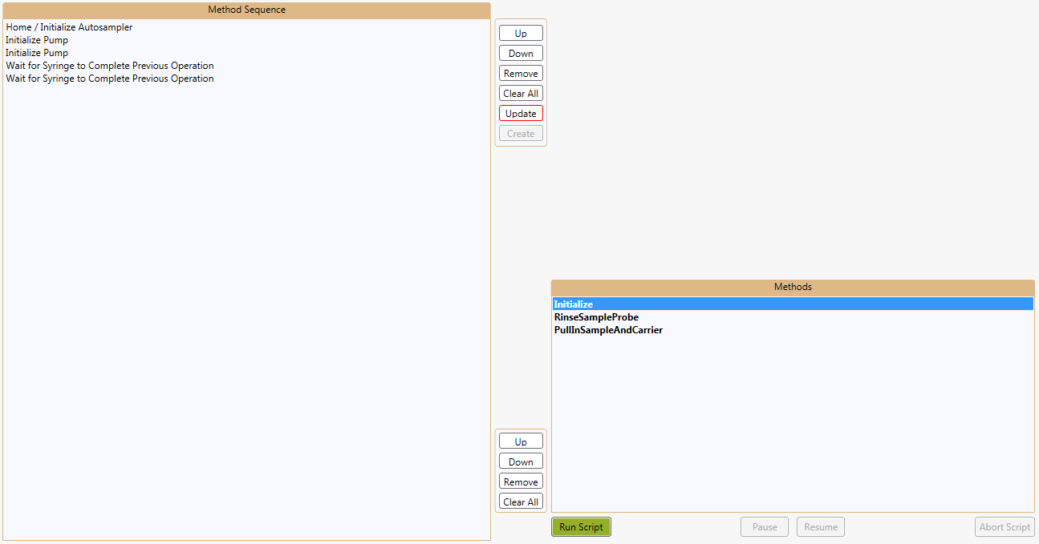

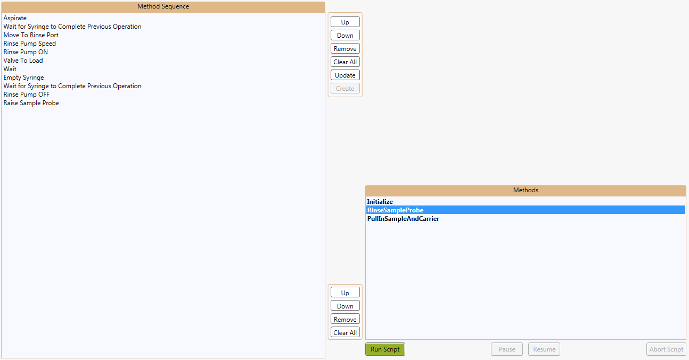

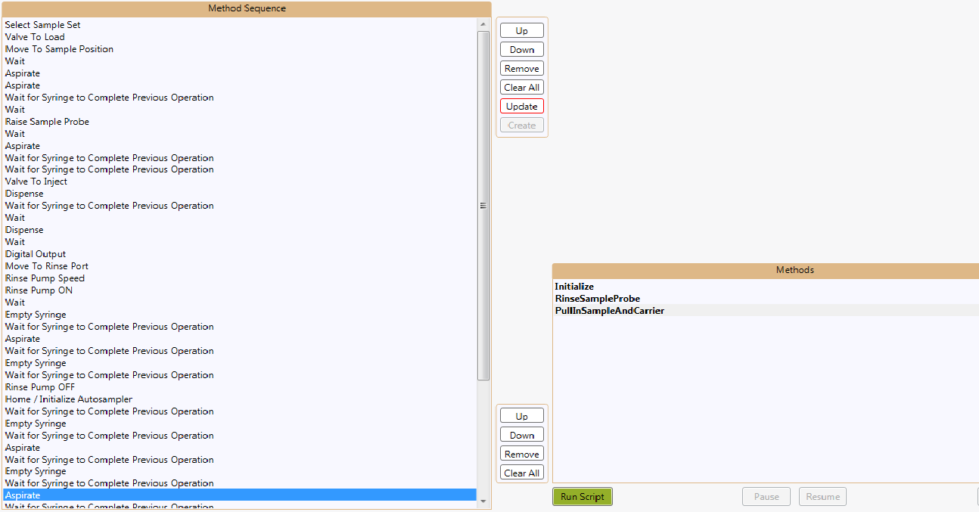

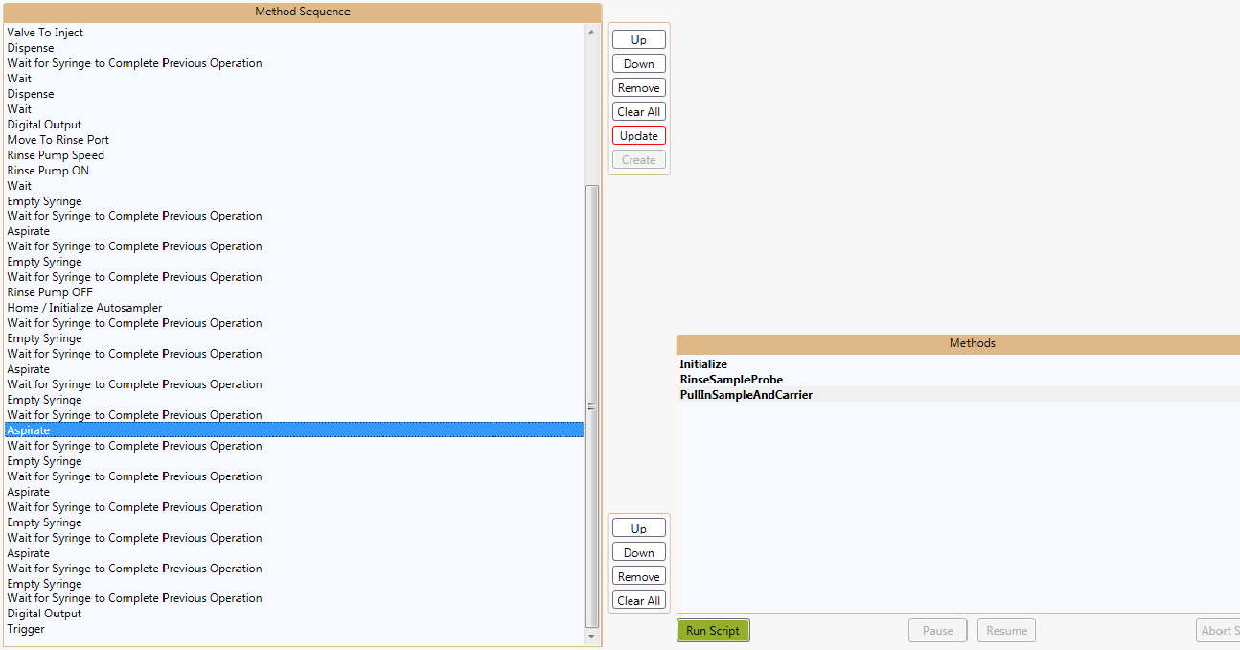

The PullInSampleAndCarrier method is broken down in more detail in the following screenshots.



Rinse the sample probe.

Empty the half-height syringe from when it pulled up the sample. Then move to the drain and prime a full barrel.

Wait 2 seconds for the sample to start moving and then send the signal to begin acquiring.

Wait 2 seconds for the momentum to stop, then dispense the sample at acquisition speed (10 uL/min).

Dispense 250 uL to get the sample in the correct spot under the camera.

Aspirate sample and carrier.

Wait for the probe to get to the sample before aspirating.

Aspirate air to pull the sample into the sample loop.



Send the signal that the autosampler is ready to load the next sample and wait for a trigger.

Wait for full height syringe to finish dispensing and then flush by priming a full barrel 4 times.

# Sample List File

The Sample List File for the NanoSight Automation program is a simple csv or Excel file with the appropriate headers and information under the headers. An example is shown below:



Headers must be in row 1 of the file and are case sensitive. The Sample Name column is simply the name of the sample as it should appear in its output file. This will be the base name for all of the output files and the name of the directory for those files if the “Create Individual Directories For Each Sample” option is left checked in the program. The Save Directory column is the absolute path to the folder where the output files for the sample should be saved. The sub-folder for the sample will be created here if the “Create Individual Directories For Each Sample” option is left checked in the program. The Acquire Script column is the absolute file path to the NTA script file that should be ran in the NTA 3.3 program when acquiring the sample. The Process Script column is the absolute file path to the NTA script file that should be ran in the NTA 3.3 program when processing the sample after it has been acquired. Each sample can use a different acquisition and process script, even though the example uses the same for each one.

# Explanation of NanoSight Automation Signaling

NanoSight Automation sits in the middle of the CETAC Workstation and NTA 3.3 programs and coordinates the actions between them. The MVX needs to be able to signal the NS300 so that the NS300 can start acquiring the sample at the right time, and the NS300 needs to be able to signal the MVX when it is ready to acquire the next sample. The MVX is able to accomplish this through the DC I/O ports on the back in combination with script commands in the CETAC Workstation program. The MVX is inherently set up to communicate and coordinate with another piece of equipment, but the NS300 is not.

From within NTA 3.3 you are able to add a script command that will produce an arbitrary message box with whatever message you want, and the creation of new dialogue boxes is detectable programmatically, so this is what is used for signal and message passing. NanoSight Automation detects the creation of dialogue boxes created by NTA 3.3 and then communicates the signal to the MVX through its DC I/O using an Arduino. At time of writing however no extra message commands have to be added to the NTA scripts since a message automatically appears once the script has completed, this is the only signal needed by NanoSight Automation from NTA 3.3.

# Creating an NTA Acquisition Script

There are a few limitations to the acquisition scripts that can be used with NanoSight Automation. Essentially, any script that does not use commands that create a message can be used. Since the execution of a script is halted after the creation of a dialogue box until the box is closed they cannot be used in any acquisition script that will be used with NanoSight Automation. The only dialogue box that NanoSight Automation looks for is the one automatically generated at the end of the script by the NTA program, so any additional boxes that are created will halt the script forever. If more complex behavior is desired from NanoSight Automation then the code will have to be changed to support to it.

# Creating an NTA Processing Script

Everything mentioned in the Creating an NTA Acquisition Script section also applies here, but there is one additional note. It is assumed that the results of processing will want to be saved or “exported” as it is called in NTA 3.3, so after running a processing script NanoSight Automation will look to see if the script called the export command, and if not then it clicks the export button itself and exports with the default export settings.

# Creating a CETAC Workstation Script

Essentially the script can do anything, but NanoSight Automation expects there to be a Digital Output command on pin 1 (3-4 second duration recommended) that is the signal to start the NTA 3.3 acquisition script. Then it expects another Digital Output command on pin 1 just before a Trigger command that waits for a trigger on pin 1. The second Digital Output is to let NanoSight Automation know that the script has finished its rinse after the sample and is ready to start loading the next sample. The Trigger command forces the script to wait until NanoSight Automation gives the signal to start the next sample. NanoSight Automation checks to see if the script is still running after sending the last trigger to the autosampler, and if it is still running the assumption is that there were more samples selected in CETAC than there were in the Sample List File, so the script is aborted and an error message is displayed. This is to avoid injecting samples that won’t be acquired and thus losing a sample, so there can be no other commands or methods after the Trigger command.

Basic structure:

Initialization

Commands to aspirate a sample and inject it into the NanoSight

Digital Output (The NTA acquisition script will begin as soon as this signal is sent.)

Probe and tubing rinses

Digital Output

Trigger

# Arduino Wiring

Digital I/O port 7 should be connected to the left OUT port 1 on the MVX. The GND port should be connected to the right OUT port 1 on the MVX. Digital I/O port 5 should be connected to the IN port 1 on the MVX.





# Troubleshooting

If there are any communication errors with the Arduino check all of the connections between it and the MVX and power cycle the Arduino by unplugging it from the USB port, wait 20-30 seconds, and plug it back in.

# Miscellaneous

* The volume of air that needs to be pulled up behind the sample to get it into the sample loop is ~250 uL. This is if the 6-port valve module is on the left side of the MVX. Originally it was on the right side and had a shorter probe tubing length. If the configuration is changed back then the volume is ~210 uL.
* The volume of PBS that is needed to push the sample from the sample loop into the NS300 is ~200 uL.
* The final dispense speed while the NanoSight is acquiring is 10 uL/s.
* The maximum dispense speed through the NanoSight should be 3000 uL/s.